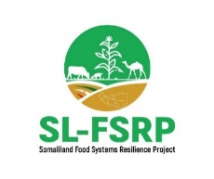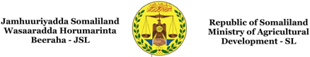
REPUBLIC OF SOMALILAND
Ministry of Agricultural Development (MoAD)
Somaliland Food Systems Resilience Project (SL-FSRP)
Project ID: P177816
Project Coordination Unit (PCU)
ENVIRONMENTAL AND SOCIAL MANAGEMENT PLAN (ESMP)
Construction of the Office Building for the Ministry of Agricultural Development (MoAD)
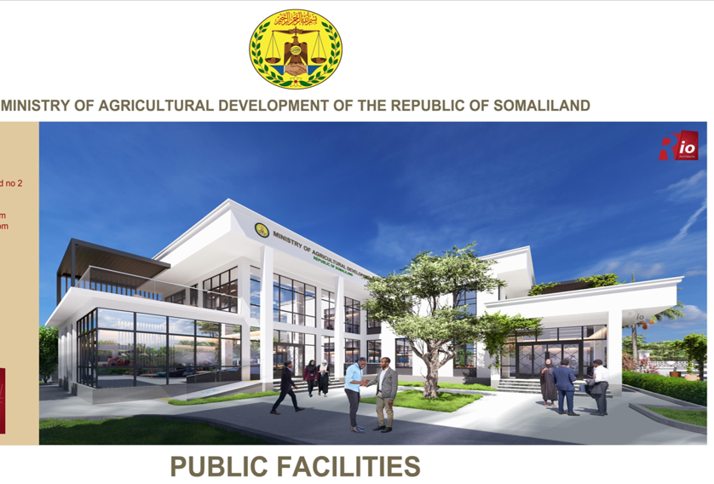

Submitted by:
Abdisamad Yusuf Kahin
Social Safeguards Specialist, SL-FSRP Project Coordination Unit
September 2026

Table of Contents
Executive Summary iv
1. Introduction 1
1.1 Purpose of the ESMP 1
1.2 Methodology 2
2. Sub-project Description 2
3. Environmental and Social Baseline Description 4
3.1 Environmental Baseline 4
3.2 Social Baseline 5
4. Legal and Regulatory Framework 6
4.1 The National Framework 6
4.2 The World Bank Framework 8
5. Environmental and Social Risks and Impacts – Overview 9
5.1 The Sub-project’s Positive Impacts 9
5.2 The Expected Negative E&S Risks and Impacts 9
6. Environmental and Social Management Plan 11
7. Implementation Arrangements 20
7.1 Government Responsibilities 20
7.2 Contractors and Sub-contractors 20
7.3 Project-Specific Contractual E&S Requirements 21
7.4 Priority Pre-Construction Clearance Conditions 23
7.5 Contractor C-ESMP, MSIPs and Records 23
7.6 General RFB E&S Requirements 23
7.7 Reporting Arrangements 24
8. Public Consultation and Feedback 24
9. Grievance Mechanism 25
10. ESMP Implementation Budget 26
11. References 26
12. Annexes 28
Annex 1: Technical Designs / Site Layout Drawings 28
Annex 2: Official Confirmation of Land Ownership 30
Annex 3: Notarized Declaration on the Privately Leased Room 31
Annex 4: Brief Description of the Applicable ESSs 33
Annex 5: Minutes – High-Level Project Kick-off and Safeguarding Briefing Meeting 35
Annex 6: Photographs – Stakeholder Consultation and Safeguarding Meetings 37
Annex 7: Attendance Sheet – High-Level Project Kick-off and Safeguarding Briefing Meeting —
Annex 8: Minutes – Technical Workshop on E&S Safeguards and Design 39
Annex 9: Attendance Sheet – Technical Workshop on E&S Safeguards and Design 41
Annex 10: MoAD Office Building E&S Screening Checklist 43
Annex 11: Demolition and Relocation E&S Management Matrix 48

List of Tables
Table 1: Environmental and social risks and impacts during construction and operation – overview 10
Table 2: Environmental and Social Management Plan 11
Table 3: Environmental and Social Monitoring Plan 16
Table 4: Capacity Building Plan 19
Table 5: Institutional partners’ responsibilities 20
Table 6: Project-specific contractual E&S requirements 22
Table 7: Reporting Plan 24
Table 8: Public consultations conducted on the sub-project 24
Table 9: Indicative budgetary requirements for implementing the ESMP 26

List of Figures
Figure 1: Google Earth map indicating the location of the MoAD headquarter in Hargeisa 3

List of Abbreviations and Acronyms
Abbreviation / Acronym | Full term
BOQ | Bill of Quantities
C-ESMP | Contractor’s Environmental and Social Management Plan
E&S | Environmental and Social
EHSG | Environmental, Health and Safety Guidelines
EPRP | Emergency Preparedness and Response Plan
ESF | Environmental and Social Framework
ESMF | Environmental and Social Management Framework
ESMP | Environmental and Social Management Plan
ESS | Environmental and Social Standard
GBV | Gender-Based Violence
GIIP | Good International Industry Practice
GM / GRM | Grievance Mechanism / Grievance Redress Mechanism
LMP | Labor Management Procedures
MoAD | Ministry of Agricultural Development
MSIP | Management Strategies and Implementation Plans
OHS | Occupational Health and Safety
PAP | Project-Affected Person
PCU | Project Coordination Unit
PPE | Personal Protective Equipment
PWD | Person with Disability
RFB | Request for Bids
RPF | Resettlement Policy Framework
SEAH | Sexual Exploitation, Abuse and Harassment
SEP | Stakeholder Engagement Plan
SL-FSRP | Somaliland Food Systems Resilience Project
WB / WBG | World Bank / World Bank Group
WMP | Waste Management Plan

Executive Summary
This Environmental and Social Management Plan (ESMP) has been prepared for the construction of a new Ground+1 (G+1) office building for the Ministry of Agricultural Development (MoAD) of the Republic of Somaliland, under the World Bank-funded Somaliland Food Systems Resilience Project (SL-FSRP). The sub-project is located within the existing MoAD headquarter compound in the 26 June district, Shacab area, Hargeisa.
The current office building was built in 1993, with additional rooms added in 2017, and has outlived its capacity of approximately 150 staff. The building remains old and insufficient to accommodate the Ministry’s current workforce, which requires space for about 350 staff. The construction of a new office building will provide a modern and functional working environment, enabling staff to carry out their duties more effectively, strengthening coordination and enhancing service delivery in support of Somaliland’s agricultural sector.
The planned building is a G+1. The office design responds to a constrained 498 m² site within an active institutional compound. A compact arrangement, informed by the proposed L-shaped courtyard concept, organises reception and public-facing functions, administrative offices, management accommodation, meeting and coordination spaces, records and storage, staff amenities, sanitation, circulation and support rooms. The courtyard and the retained mature tree improve daylight, shade, ventilation and institutional character. The design emphasizes functionality and open space, ensuring smooth circulation and creating a collaborative working environment.
Construction will take place within the existing Ministry compound. The project-specific E&S requirements also cover the controlled demolition of , Six existing rooms those are located within the proposed construction site. Five rooms are currently occupied by the MOAD Department of Plant Protection, while one room is leased to a private occupant. The leased room has been addressed through fair compensation and an agreed ( see the notary declaration letter attached). The five MOAD rooms will be vacated, with the users relocated to alternative office space within the Ministry. Following completion of the relocation arrangements, all six existing rooms will be demolished to facilitate the proposed construction works.. In addition to that, there is a mature acacia tree within the proposed construction site which will be retained and incorporated into the building design as an important environmental and spatial asset. The compact L-shaped layout with an internal courtyard accommodates the tree while enhancing natural daylight, cross-ventilation, shading, and overall site functionality.
To identify, manage and mitigate the environmental and social risks, the project team has prepared this ESMP in consultation with ministry employees, local authorities, partners and the community around the building. Significant positive impacts are expected from the construction. The primary beneficiaries are ministry employees, together with other government agencies and members of the public who access the building. Adverse risks and impacts are mainly associated with the construction works and include risks to the occupational health and safety of workers, such as increased levels of dust, noise and vibration from the movement of vehicles and machinery; community health and safety risks; and risks associated with labour rights and management, for example child labour and sexual exploitation, abuse and harassment arising from an increase in the labour-related population at the project site. The land belongs to the Ministry of Agricultural Development; therefore no land acquisition or resettlement impacts are anticipated. The adverse environmental and social risks associated with the construction works are reversible and short term.
Environmental concerns during the construction works include dust and air pollution, which can affect air quality in the surrounding area and impact nearby residents and the workforce. To manage this, dust suppression techniques will be employed, such as regularly spraying water over debris and work areas. Barriers will be installed around the works site to contain particles, and all workers will be provided with appropriate PPE, including masks and respirators, to protect them from inhaling harmful particulates.
Noise and vibration from demolition and construction activities present another significant risk, particularly given the proximity of ministry employees, the general public and residents. To mitigate this, all works will be restricted to daytime hours. Noise-dampening equipment will be used where possible, and nearby communities will be informed about the nature, duration and timing of demolition-related noise. Workers will be provided with ear protection, and a buffer zone will be established around the site.
Occupational health and safety (OHS) risks are a top priority, as construction tasks inherently expose workers to hazards such as falling debris, heavy machinery and potential exposure to harmful materials. All workers will undergo safety training covering work protocols and emergency response procedures, and will be supplied with essential PPE, including hard hats, gloves, steel-toed boots and safety harnesses for high-risk tasks. Clear access controls will be set up to prevent unauthorized entry into the work zones, and first-aid facilities will be available on site.
Community health and safety is a priority, as employees, workers and the general public could be exposed to hazards such as falling debris, dust and increased heavy vehicle traffic. Fencing and prominent warning signs will be installed around the demolition area. Traffic control measures will be implemented, with designated routes established for demolition vehicles to avoid populated areas. Community engagement efforts will keep local residents informed of the work timeline, site hazards and safety protocols in place.
Social impacts include potential disruption to ministry work and community inconvenience due to noise and dust, child labour and SEA/SH, among others. The project’s Stakeholder Engagement Plan (SEP) will be adopted and implemented in the context of the site to keep the community involved and informed. To facilitate responsive communication, the contractor — in addition to the existing Project GRM — will put in place a site-specific grievance redress mechanism (GRM) for workers to voice concerns or complaints and receive timely responses. Communicating the benefits of the project and the expected timelines will help address community concerns and foster positive perceptions of the development.
Following the detailed E&S screening of the proposed sub-project, as per the process described in the project’s approved ESMF, the sub-project was classified as “Moderate Risk”. The project team considers that an ESMP best guides risk management for the sub-project during construction and operation. The site-specific E&S screening checklist was duly administered (see Annex 10).
This ESMP introduces the E&S risks and impacts of the sub-project during both the construction and operation phases. Key risks identified are primarily associated with the construction phase and are considered site-specific, temporary and manageable with standard mitigation measures.
This ESMP specifies the means through which the adverse environmental and social risks and impacts associated with the construction activities are either avoided or mitigated. It identifies, characterizes and manages the potential risks and impacts; lists the project-specific risks, impacts and mitigation measures; lays out institutional arrangements for implementing and monitoring the risk mitigation measures; and proposes monitoring indicators for measuring E&S performance, as well as requirements for capacity building and reporting. It shows what must be done, by whom, when and to what standard, who will monitor its implementation and when, and what the budget implications for mitigation and monitoring activities are. It further includes a description of the Project Grievance Redress Mechanism (GRM), to be applied during the construction period, and lists the stakeholder consultations conducted in the lead-up to the project design.
This ESMP is prepared in line with Somaliland regulations and the World Bank’s Environmental and Social Framework (ESF). Key plans to be implemented by the Contractor include a Labor Management Procedure (LMP), an Occupational Health and Safety (OHS) Plan, a Waste Management Plan (WMP) and a traffic management plan. The Contractor will be contractually obligated to implement this ESMP, with oversight provided by the Safeguarding team and its supervising engineers.

1. Introduction
The Republic of Somaliland, through the Ministry of Agricultural Development, has received financial support from the World Bank under the Somali Food Systems Resilience Project (S-FSRP3, P177816). The project objective is to increase preparedness against food insecurity and to improve the resilience of food systems in targeted project areas of Somaliland. The project intends to benefit an estimated 65,000 small farmers, agro-pastoralists and nomadic pastoralists, of which at least 30 per cent will be female.
The project has the following components and sub-components:
Component 1: (Re-)Building Resilient Agricultural Production Capacity
Sub-component 1.1 Crop and Livestock Research, Extension and Seed Systems
Sub-component 1.2 Community Engagement and Technology Transfer
Sub-component 1.3 Digital Agriculture and Rangeland Solutions and Data Systems
Component 2: Supporting the Sustainable Development of Natural Resources for Resilient Agricultural Landscapes
Sub-component 2.1 Water Availability for Crops and Livestock
Sub-component 2.2 Rangeland Management
Component 3: Getting to Market
Sub-component 3.1 Farmer Producer Organizations and Agrifood Enterprises
Sub-component 3.2 Market Infrastructure and Enterprise Development
Sub-component 3.3 Access to Finance
Component 4: Promoting a Greater Focus on Food Systems Resilience in Policymaking
Sub-component 4.1 Institutional Infrastructure and Capacity Development for the Crops Sector
Sub-component 4.2 Institutional Infrastructure and Capacity Development for the Livestock Sector
Sub-component 4.3 Institutional Infrastructure and Capacity Development for Rangelands Management
Component 5: Contingent Emergency Response Component
Component 6: Project Management

The Project is financing the construction of an office building for the Ministry of Agricultural Development headquarters in Hargeisa Under component 4: Promoting a Greater Focus on Food Systems Resilience in Policymaking, Sub-component 4.1 Institutional Infrastructure and Capacity Development for the Crops Sector.
1.1 Purpose of the ESMP
In line with the Project’s overall Environmental and Social Management Framework (ESMF), the objective of this ESMP is to provide management actions to mitigate adverse site-specific risks and impacts, consistent with national frameworks, the relevant World Bank Environmental and Social Standards (ESSs) of the Environmental and Social Framework (ESF), the World Bank Group’s Environmental, Health and Safety Guidelines (EHSGs) and Good International Industry Practice (GIIP). The implementation of this sub-project will be based on the World Bank’s ESF and the relevant provisions of the EHSGs, as the most stringent framework.
This ESMP also identifies the potential environmental and social risks and impacts of the sub-project and details the mitigation, management, monitoring, capacity-building and reporting measures to be taken during the construction and operation phases. It serves as a practical tool for the Contractor, the supervising agency and the PCU safeguarding team to guide the management of E&S issues.

The plan is a live document and will be reviewed and updated as necessary throughout the sub-project lifecycle, following the annual environmental and social audits.

1.2 Methodology
The preparation of this ESMP was based on stakeholder consultations, field visits and a review of all project-related documentation, including design documents. The main reference documents included the World Bank ESF and ESS good-practice documents and guidelines, relevant national legislation, policies and guidelines, international covenants and treaties, and the WB ESSs and their relevance to the project. Consultations with key stakeholders were conducted on 4 September 2026 to identify and discuss potential environmental and social (E&S) risks and impacts associated with the proposed activities, and to obtain stakeholder input on appropriate mitigation measures and the proposed Environmental and Social Management Plan (ESMP). . The aim was to provide input on the broad content areas of the ESMP: E&S baseline information, social and environmental risks and their mitigation, and the handling of project-related grievances. The participants were representatives of relevant site users and institutional leadership, who provided input and suggestions on improving the ESMP. The main suggestions and how they will be addressed are set out in Annexes 5 to 9. The ESMP will be disclosed in country and will be implemented throughout the construction period.

2. Sub-project Description
This ESMP is prepared for the construction of a new office building to serve as the headquarters of the Ministry of Agricultural Development (MoAD) of the Republic of Somaliland, accommodating staff, hosting official meetings and facilitating the coordination of agricultural programmes and services across Somaliland.
The new building will provide a modern and functional working space for the Ministry’s staff, enabling them to carry out their duties effectively, improve coordination and deliver services that support the agricultural sector across Somaliland. Understanding this operational purpose is essential for analysing the potential environmental and social impacts during the building’s use phase. The construction site is georeferenced as follows: Ministry of Agricultural Development property at Shacab area, Presidential Palace area (GPS: 9°33′28.65″N, 44°3′6.52″E)
Figure 1:
Google Earth map indicating the location of the MoAD headquarter

Project components and activities
The project involves the construction of a new two-storey office building. The design responds to a constrained 498 m² site within an active institutional compound. A compact arrangement, informed by the proposed L-shaped courtyard concept, organises reception and public-facing functions, administrative offices, management accommodation, meeting and coordination spaces, records and storage, staff amenities, sanitation, circulation and support rooms. A mature acacia tree within the proposed construction site will be retained and incorporated into the building design as an important environmental and spatial asset. The compact L-shaped layout with an internal courtyard accommodates the tree while enhancing natural daylight, cross-ventilation, shading, and overall site functionality. In addition to that there is a small nursery which belongs to the institution. The nursery currently includes 36 implanted fruit trees. The MOAD will relocate those trees into another area before demolition.
Based on the Bill of Quantities (BOQ), the key activities include the following (see Annex 1 for the design layout):
- Substructure: site clearance (demolition of 6 existing MoAD offices including 1 leased room , with compensation of the leased room solved as prove attached ), the users of the five rooms to be demolished are MOAD staff and will be relocated by the MOAD. Excavation for foundations, hardcore filling, removal of excess soil, and construction of reinforced concrete foundations and a retaining wall.
- Superstructure: construction of reinforced concrete columns, beams and slabs for the ground and first floors.
- Walling and finishes: infilling with smooth-dressed hollow blocks, internal and external plastering, painting, floor and wall tiling.
- Installations: installation of PVC windows, semi-solid core wooden doors and complete sanitary fittings (WCs, washbasins, etc.) for all floors.
- Services: prime cost sums are allocated for electrical installation, plumbing and drainage installation, and decoration.

- Location: the project site is located at coordinates 9°33′28.65″N, 44°3′6.52″E, within the existing MoAD headquarter compound at Shacab area, 26 June District, Hargeisa. GPS coordinates and architectural drawings of the building will be included in the Contractor’s ESMP (C-ESMP). The site is in an urban area and does not contain or border any sensitive ecosystems, water bodies or households.
- Timeline and workforce: the expected construction duration is 12–18 months. The project will employ both skilled labour (masons, carpenters, steel benders, plumbers and electrical technicians) and unskilled local labour, with affirmative action for both vulnerable and minority job seekers. Qualified engineers and environmental specialists will be engaged to uphold the contractual standards and requirements. In Somaliland the official working hours are eight per day, typically from 8:00 a.m. to 5:00 p.m., with scheduled breaks included.
- Materials and machinery: materials include ready-mix concrete from a local plant, reinforcement steel, cement, aggregates, blocks, tiles, paint, PVC and wood. Borrow materials, including sand and aggregates, shall be sourced from legally authorized and government-designated quarry sites outside Hargeisa, in accordance with applicable environmental, social, and regulatory requirements from Hargeisa local government. . Machinery will include excavators, trucks, compactors and concrete vibrators. During construction the contractor will bring water from outside, so the MoAD water system will not be used; the contractor will also provide temporary, clean and segregated sanitation facilities such as establishing temporary toilets.. The contractor will implement a Waste Management Plan (WMP), which includes segregating waste into labelled bins (general and hazardous), storing hazardous materials such as fuel, oil and paint in a secure bunded area, and disposing of all waste at local government-approved sites.
Access: The site is readily accessible from the main road. The contractor shall plan and schedule the delivery of construction materials during off-peak hours, where practicable, to minimize traffic disruption, congestion, noise, and inconvenience to MoAD working schedule, nearby Offices/businesses and road users.
3. Environmental and Social Baseline Description

3.1 Environmental Baseline
The sub-project is situated in a built-up, urban environment within the existing Ministry of Agricultural Development compound in Hargeisa.
- Living environment (flora and fauna): the site is pre-disturbed with minimal vegetation, described as having no bushes or shrubs. There are no protected areas, critical habitats or known endangered species on or near the site. Only minor occurrences of common urban fauna, such as birds and insects, may be observed, and these are of minimal ecological concern. The contractor will be required to conduct a pre-construction walkover to confirm the absence of any sensitive ecological features. If any fauna of ecological importance or protected species is unexpectedly observed during construction, work in the immediate area will be halted, the E&S team will be informed, and appropriate mitigation measures will be implemented to ensure their protection.
- Non-living environment: the project site is in a flat, fenced urban area that is not naturally prone to significant soil erosion. Nonetheless, construction activities, particularly excavation for foundations, may temporarily disturb the soil and create localized erosion risks. To mitigate this, the contractor will apply standard control measures, including soil compaction, temporary cover and proper site drainage management. Hargeisa’s climate is hot and semi-arid, with year-round high temperatures averaging between 25°C and 35°C. Rainfall is seasonal, occurring mainly during the Gu rains (April–June) and the shorter Deyr rains (October–December), while the remaining months are largely dry.
- Air quality and noise: the primary environmental concerns related to the project are air quality (dust from construction) and noise. The sub-project is located in a densely populated urban district where baseline air quality and noise levels are already influenced by traffic. During the 12–18-month construction phase, temporary impacts are expected, including dust from site clearance, excavation, vehicle movement and material stockpiling, as well as gaseous emissions (SOx, NOx) from machinery and generators. Noise and vibration will also increase due to heavy equipment operations such as excavators and trucks, which will be required primarily during the initial stages of construction. These impacts are short term and will be managed through C-ESMP measures, including regular water spraying for dust suppression, covering stockpiles, maintaining equipment to minimize emissions and restricting noisy activities to standard daytime working hours.

3.2 Social Baseline
- Socio-economic context: the sub-project is located in 26 June, a densely populated district of Hargeisa. The current estimate for Hargeisa’s urban population is 1.8 million people, although no official census has been published. In Somaliland the population predominantly consists of youth. The urban area grows by approximately 4.2 per cent per year. Population numbers have fluctuated due to pastoral and internal displacement movements. Livelihoods in 26 June district are diverse, ranging from formal employment to small-scale traders.
- Livelihoods and employment: Hargeisa is the main economic centre of Somaliland. Waaheen and Xisbiga markets are the country’s largest markets and are located in Hargeisa. The economy is largely informal, and enterprises are characterized by low productivity and wages and by goods that are not exported. The fastest-growing sectors in recent years have been hotels, agriculture, health and education. Sixty-four per cent of the city’s households make their living from wage labour. Urban income arrives through informal business, but informal-sector workers are in low-skill jobs and are often underemployed. This applies in particular to urban women and youth as well as IDPs. Low-income households are vulnerable to shocks.
- Gender-based violence (GBV): Somaliland is a patriarchal society with firmly entrenched gender roles that often subjugate women and girls. GBV is pervasive, particularly female genital mutilation/cutting (FGM/C), early marriage and psychological abuse. The most affected are young girls and women from IDP camps, who are vulnerable to rape and other forms of sexual abuse. After decades of war and conflict, women, girls and children have been displaced and remain vulnerable to gender-based violence due to high insecurity in the camps, limited access to justice and lack of protection. Many gender-based violence cases go unreported and perpetrators go unpunished.
- Access to water and electricity: access to safe and reliable water in Hargeisa is constrained by limited supply, increasing demand, inadequate infrastructure and water-quality concerns. Many households, particularly low-income households, do not have reliable access to piped water and depend on private water vendors, shallow wells, boreholes and other alternative sources, often at relatively high cost. The availability and quality of groundwater are also concerns in some areas, particularly where wells are poorly maintained or vulnerable to contamination. Access to electricity in Hargeisa is good but privately owned, which makes it relatively very costly.
- Solid waste management: solid waste management in Hargeisa remains a significant environmental and public health challenge due to increasing waste generation, limited waste collection services, inadequate disposal infrastructure and limited recycling facilities. In some areas, indiscriminate dumping of solid waste is common, including disposal along roadsides, in open spaces and in drainage channels. Construction and demolition waste presents a particular challenge, as appropriate and regulated disposal facilities are limited. Where municipal disposal sites are unavailable within a reasonable distance of the project site, construction waste may be transported to an approved disposal location/ process identified in coordination with the Hargeisa local authorities. The contractor shall not dispose of construction waste in unauthorized locations, drainage channels, open spaces or residential areas. The Hargeisa Municipality and local authorities will guide the contractor, where necessary, to an appropriate and authorized location for the disposal of construction waste and other project-generated waste.
- Cultural heritage: there are no known sites of cultural or archaeological significance within the sub-project area. A chance-finds procedure will be included in the contractor’s ESMP.

4. Legal and Regulatory Framework
This chapter focuses on the relevant provisions of the key Somaliland policy, legal, regulatory and institutional framework related to the activities to be carried out under this project. It also includes the ESF provisions required by the World Bank and the associated Environmental, Health and Safety Guidelines (EHSGs) and Good International Industry Practice (GIIP) to which the borrower is obliged. It further presents an analysis of the gaps between national and World Bank provisions, together with the relevant international conventions and treaties that Somaliland has ratified. The sub-project will be implemented in accordance with the national laws of Somaliland and the Environmental and Social Framework and applicable standards of the World Bank.

4.1 The National Framework
All activities will comply with the relevant laws and regulations of the Republic of Somaliland, including the Constitution and all relevant legislation.

4.1.1 Constitution of the Republic of Somaliland
The Constitution of the Republic of Somaliland, 2001, provides the overarching legal framework for the protection of human rights, environmental resources, land and property, labour rights, vulnerable groups, women’s rights and public participation. The Constitution was approved through a referendum on 31 May 2001 and provides the basis for the protection of these rights in the implementation of development activities in Somaliland.
The following provisions are particularly relevant to the environmental and social management of the project:
- Article 8 – Equality of Citizens. The Constitution establishes the equality of citizens and provides that citizens shall have equal rights and duties before the law. This principle is relevant to project implementation by requiring non-discriminatory access to project benefits, opportunities, consultation processes, employment and grievance mechanisms.
- Article 12 – Public Assets, Natural Resources and Indigenous Production. The Constitution recognizes land and natural resources as important national resources and provides principles concerning their protection and management. Project activities should therefore ensure the sustainable and responsible use of natural resources and avoid unnecessary environmental degradation.
- Article 17 – Health. The Constitution places responsibility on the State to promote public health and to provide for measures addressing communicable diseases and public welfare. This is relevant to project-related occupational health and safety, community health and safety, disease prevention, sanitation, waste management and the control of health risks arising from construction activities.
- Article 18 – The Environment and the Relief of Disaster. The Constitution provides that the State shall give special priority to the protection and safeguarding of the environment, which is essential for the well-being of society, and to the care of natural resources. It further provides that the protection of the environment and the prevention of environmental damage shall be determined by law. This provides a direct constitutional basis for the environmental assessment and management of project activities. Accordingly, the project shall incorporate measures for pollution prevention, waste management, protection of natural resources, occupational and community health and safety, and mitigation of environmental impacts.
- Article 19 – Care of Vulnerable Members of Society. The Constitution provides that the State shall be responsible for the health, care, development and education of mothers, children, persons with disabilities who have no one to care for them, and persons who are unable to care for themselves. Project consultations, livelihood measures, access to project benefits and grievance mechanisms should take into account the circumstances and needs of vulnerable persons and households.
- Article 20 – Work, Trade and the Welfare of Employees. The Constitution recognizes the right and duty of able citizens to work and provides for the creation of employment and skills development. Working conditions, including those of young people and women, shall be regulated by labour law; employees have a right to appropriate payment; forced labour is prohibited; and the State shall promote employee support systems, insurance and safety. Contractors and other project workers shall be provided with fair employment conditions, appropriate remuneration, safe working conditions and protection from forced labour and other prohibited labour practices.
- Article 21 – Implementation and Interpretation. The legislative, executive and judicial branches of the State, as well as local governments at regional and district levels, are bound by the constitutional provisions concerning fundamental rights, which shall be interpreted consistently with the international human rights conventions and international law referred to in the Constitution.
- Article 22 – Political, Economic and Social Rights. The Constitution provides citizens with the right to participate in political, economic, social and cultural affairs. For the project, this supports meaningful stakeholder and community engagement, particularly the participation of affected communities, women, vulnerable groups and other relevant stakeholders in project planning and implementation.
- Article 24 – Right to Life, Security of the Person and Respect for Reputation. The Constitution protects the right to life and personal security and recognizes the right of every person to respect for their dignity and reputation. Project implementation shall therefore include appropriate measures to prevent accidents, injuries, violence, abuse and other risks to workers and communities.
- Article 28 – Right to Sue and Defend. Every person has the right to institute proceedings before a competent court and the right to defend themselves before a court. This complements project-level grievance mechanisms: the project’s Grievance Redress Mechanism shall provide an accessible means for affected persons and communities to raise concerns and seek resolution without restricting their legal rights.
- Article 31 – Right to Own Private Property. Every person has the right to own lawfully acquired private property, which shall not be expropriated except for reasons of public interest and subject to proper compensation. Where project activities affect lawfully acquired private property, the applicable legal procedures and compensation requirements shall be followed.
- Article 32 – Freedom of Public Demonstration and Expression of Opinion. The Constitution protects freedom of expression and the right of citizens to organize or participate in peaceful meetings, subject to law. Project stakeholders should have appropriate opportunities to express concerns, provide feedback and participate in consultations without intimidation or discrimination.
- Article 34 – Duties of the Citizen. The Constitution places duties on citizens, including the duty to respect the Constitution and the laws and to care for, protect and save the environment. This reinforces the shared responsibility of government institutions, contractors, communities, workers and other stakeholders for environmental protection.
- Article 36 – Rights of Women. The rights, freedoms and duties established under the Constitution are to be enjoyed equally by women and men, subject to matters specifically ordained by Islamic Sharia. The Constitution further provides for women’s protection from practices injurious to their person and dignity, recognizes women’s rights concerning property, and provides for women’s education and skills development. This is relevant to project gender considerations, women’s participation in consultation and decision-making, equal access to project opportunities, protection from harassment and abuse, and consideration of women’s property and livelihood rights.

4.1.2 Relevance to environmental and social management
The Constitution of the Republic of Somaliland provides a strong national constitutional basis for integrating environmental and social safeguards into project planning and implementation. In particular, Articles 8, 12, 17, 18, 19, 20, 21, 22, 24, 28, 31, 32, 34 and 36 are relevant to the project because they address equality, natural resources, health, environmental protection, vulnerable groups, labour and worker safety, fundamental rights, participation, personal security, access to justice, private property, public expression, environmental responsibility and women’s rights.
Accordingly, the project shall implement this ESMP and the associated environmental and social instruments in a manner consistent with the Constitution and other applicable Somaliland legislation and regulations. Where project-specific instruments address matters such as land acquisition, compensation, labour management, stakeholder engagement, grievance redress, community health and safety, gender-based risks, pollution prevention, waste management and protection of vulnerable groups, these measures shall be implemented as applicable contractual and management requirements for the implementing agencies and contractors.

4.1.3 Relevant national legislation
The implementation of the FSRP project in Somaliland shall comply with the applicable laws, regulations, policies, standards and institutional requirements of the Republic of Somaliland relating to environmental protection, land and property, labour and employment, public health, construction, natural resource management, gender and community participation. The following legal and policy instruments are particularly relevant:
- Constitution of the Republic of Somaliland (2001);
- Environmental Protection and Management Act, 2024;
- Environmental and Social Impact Assessment and Audit Regulations, 2024, where applicable;
- construction-related laws, regulations, permit requirements and municipal requirements applicable in Somaliland;
- applicable public health legislation and regulations;
- applicable labour and employment legislation and regulations in Somaliland;
- applicable land, property and land-use legislation and procedures;
- applicable policies and procedures relating to gender equality, women’s rights, vulnerable and disadvantaged groups, and protection from gender-based violence and other forms of abuse;
- applicable regulations and requirements governing waste management, pollution prevention, occupational health and safety and protection of natural resources; and
- other applicable environmental and social policies, regulations, guidelines and administrative requirements issued by the competent Somaliland authorities.

4.2 The World Bank Framework
As the sub-project is classified as having a Moderate environmental and social risk, a full Environmental Impact Assessment (EIA) is not required. This site-specific ESMP will serve as the primary instrument for identifying, assessing and managing all potential risks and impacts.
In the absence of specific national standards for air quality, water quality or noise, or where such standards are less stringent, the project will adhere to internationally recognized benchmarks, including the WB ESF, the World Bank Group’s General EHS Guidelines and, where applicable, World Health Organization (WHO) standards. These standards will guide all management and monitoring activities throughout the project lifecycle.
World Bank Environmental and Social Framework (ESF). The following Environmental and Social Standards (ESSs) are relevant to this project (see Annex 4 for key descriptions):
- ESS 1: Assessment and Management of Environmental and Social Risks and Impacts
- ESS 2: Labor and Working Conditions
- ESS 3: Resource Efficiency and Pollution Prevention and Management
- ESS 4: Community Health and Safety
- ESS 5: Land Acquisition, Restrictions on Land Use and Involuntary Resettlement
- ESS 8: Cultural Heritage
- ESS 10: Stakeholder Engagement and Information Disclosure
World Bank Group EHS Guidelines. The project will adhere to the WBG General Environmental, Health and Safety Guidelines (EHSGs). These are technical reference documents that define Good International Industry Practice (GIIP) for managing EHS issues in a sustainable manner. For this civil works project they are critically important, as they provide a practical and authoritative framework for implementing effective mitigation measures related to occupational health and safety (e.g. use of PPE, site safety protocols), community health and safety (e.g. site security, traffic management) and environmental pollution control (e.g. managing dust, noise and waste) during construction and operation.
Where Somaliland regulations and World Bank policies differ, the World Bank standards will prevail and will be applied. This ESMP, along with the associated plans, S-FSRP frameworks and manuals (ESMF, RPF, IPMP, LMP, WMP, GM, SEP and others), is legally binding on the contractor. The Contractor is required to prepare its C-ESMP upon signing the work contract and before commencing work, based on the management framework of this ESMP, the World Bank ESF and the GIIP included in the EHSGs. A detailed gap analysis has been developed within the project-approved ESMF.

5. Environmental and Social Risks and Impacts – Overview

5.1 The Sub-project’s Positive Impacts
The agricultural sector has seen recent vulnerability due to recurrent natural and man-made disasters, including fluctuating levels of conflict, poverty, economic pressure, political uncertainty, drought, floods and epidemics. The construction of the headquarters of the Ministry of Agricultural Development will provide a conducive environment and the space to plan, organize and develop policies that help address the challenges facing the agricultural sector in Somaliland.

5.2 The Expected Negative E&S Risks and Impacts
Based on the site visits conducted by E&S specialists, the stakeholder consultation meetings (4 September 2026), and the applicable ESSs of the World Bank’s ESF and the parent ESMF of the S-FSRP, the following site-specific E&S risks and impacts have been identified for the new construction sub-project of the MoAD headquarters.
Table 1: Environmental and social risks and impacts during construction and operation – overview
Risk category | Key risks and impacts | Risk rating
ESS 1: E&S Assessment and Management | - Inadequate implementation or monitoring of the ESMP, leading to unmitigated impacts.  - Inadequate inclusion of vulnerable and minority groups. | - Moderate during construction  - Minor during operation
ESS 2: Labor and Working Conditions | - A wide variety of OHS hazards for workers (over-exertion, work at heights, being struck by objects, exposure to dust, chemicals, hazardous or flammable materials, falling objects, injuries, electrocution, slips and falls, confined spaces and excavations) during demolition and construction activities.  - Potential non-compliance with labour laws (child or forced labour).  - Labour disputes over terms and conditions, including wages, working hours, payment delays, health and safety concerns and working conditions.  - Violation of the signed code of conduct for workers, including GBV and SEA/SH.  - Discrimination in the workplace, including unequal inclusion opportunities for women and minority groups, which could extend to the operation phase.  - Lack of a functional workers’ grievance mechanism. | - Moderate during construction  - Minor during operation
ESS 3: Resource Efficiency and Pollution Prevention | - Intensive use of water, raw material and energy resources. Such as Fuel for generators.  - Air pollution (dust, vehicle emissions); noise and vibration from machinery.  - Soil and water contamination from improper management of waste and hazardous material storage and disposal, including construction waste.  - Lack of a functional GM. | - Moderate during construction  - Moderate during operation
ESS 4: Community Health and Safety | - Safety hazards for MoAD staff and visitors from construction activities and debris; risk of the spread of communicable diseases from the workforce.  - Potential risks of intimidation, abuse or conflict between security personnel and community members, especially at project sites.  - Traffic and road safety hazards due to transporting staff, material, equipment and waste to and from the worksite.  - Lack of preparedness for emergencies (e.g. fire, accidents) could lead to harm to local communities.  - Gender-based violence within the community brought by workers.  - Security risks to assets, people and the community around the construction site. | - Moderate during construction  - Moderate during operation
ESS 5: Land Acquisition, Restrictions on Land Use and Involuntary Resettlement | - Risk of construction being on land not exclusively owned by the Ministry, inadequate land ownership documentation, and similar issues. | - Minor (the land is owned by the government)
ESS 8: Cultural Heritage | - Risk of the contractor exhuming artefacts or other items of special cultural and traditional interest during excavation. | - Moderate during construction
ESS 10: Stakeholder Engagement | - Exclusion of certain groups (e.g. women, minority groups, persons with disabilities) from consultation; lack of access to information or to a functional grievance mechanism, leading to unresolved complaints. | - Substantial during construction  - Substantial during operation

6. Environmental and Social Management Plan
Table 2 below proposes E&S mitigation measures, including methods, responsibilities, frequency and cost planning, for alleviating the adverse risks and impacts during the construction and operation phases of the sub-project.
Table 2: Environmental and Social Management Plan
# | Risks / impacts | Mitigation measures | Methods / tools / resources | Responsibility | Project phase | Timeline / frequency | Cost (USD)
1 | Inadequate E&S Management (ESS1): failure to manage risks as planned; inadequate assessment and management of E&S risks. | - Develop this detailed ESMP based on the ESMF. Integrate all E&S plans (LMP, OHS, SEP, GRM, WMP, GBV Plan) into project design and contracts.  - Increase knowledge on the World Bank’s ESF and the World Bank Group’s EHSGs. | - Contractual clauses  - C-ESMP approval process  - Qualified personnel | - Contractor  - PCU | - Construction | - Pre-construction and throughout construction | - Included in project management budget
2 | Labour Risks (ESS2): child/forced labour, gender exclusion, lack of a worker GRM, clear employment terms and conditions | - Implement the Labor Management Procedures (LMP).  - Verify worker ages (no one under 18); prohibit forced labour.  - Actively recruit women for suitable roles.  - Raise awareness among all project implementers, contractors and primary suppliers on the requirements and implementation of the inclusion plan.  - Promote inclusion of disadvantaged and vulnerable groups in consultations and access to project benefits.  - All workers shall receive clear information on their employment terms and conditions, including job description, duration of employment, working hours, wages, benefits, leave, and termination arrangements, in a language they understand.  - Promote diversity in recruitment, including disadvantaged and vulnerable groups, PWDs and women; quotas for gender and PWDs may be required.  - Establish and publicize a confidential worker GRM. | - LMP document  - Worker contracts, ID checks  - Code of Conduct  - Worker GRM procedure | - Contractor and PCU  - MoAD (during operation) | - Construction  - Operation (except for child/forced labour) | - Throughout construction  - Throughout operation, where applicable | - Included in contract price for implementation  - Included in project management budget for support  - Included in operational cost of the MoAD
3 | (ESS2) Lack of adequate Occupational Health and Safety (OHS) measures. | - Provide workers with clean water and segregated, clean sanitation facilities.  - Provide all workers with appropriate PPE and conduct mandatory daily/weekly OHS toolbox talks.  - Provide hearing protection where necessary (where the sound level over 8 hours reaches 85 dB(A)), in compliance with the EHSGs.  - Use acoustic insulation materials, isolation of the noise source and other engineering controls.  - Address vibration hazards by selecting low-vibration equipment, installing vibration-dampening systems and limiting exposure time, as advised by the EHSGs for physical hazards.  - Provide temporary shelters to protect workers against adverse weather and for use as rest areas, as per EHSG recommendations.  - Regularly monitor weather conditions for outdoor operations and implement adaptive work schedules.  - Modify work–rest cycles based on temperature and environmental conditions to prevent heat or cold stress.  - Ensure proper training and licensing of operators of industrial vehicles, emphasizing safe operation of such equipment in line with EHSG requirements.  - Develop and enforce operational protocols, including rights of way, site speed limits, mandatory vehicle inspections and specific operating rules and procedures.  - Use mechanical aids to reduce physical exertion associated with manual handling tasks, in accordance with EHSG ergonomic principles.  - Integrate regular rest breaks, stretching exercises and job rotation into work schedules to reduce repetitive strain and fatigue. | - LMP document  - PPE and OHS training records  - Written employment terms and conditions | - Contractor and PCU  - MoAD (during operation) | - Construction  - Operation (relevant only to employment terms and conditions) | - Throughout construction  - Throughout operation, where applicable | - Included in contract price for implementation  - Included in project management budget for support  - Included in operational cost of the MoAD
4 | Code of Conduct (CoC) violations and GBV/SEAH cases. | - Implement and monitor the GBV/SEA/SH Prevention and Response Plan.  - Hold GBV sensitization sessions for community members.  - Hold GBV awareness sessions for site workers.  - Engage a dedicated specialist to support oversight and management of these risks.  - Require workers to sign a strict CoC that includes clear penalties in case of violation.  - Include a dedicated GBV/SEAH mechanism within the workers’ GRM. | - GBV/SEA/SH Prevention and Response Plan  - Code of Conduct within the written work agreement  - Sensitization sessions  - GBV/SEAH dedicated GM | - Contractor and PCU  - MoAD (during operation) | - Construction  - Operation, where applicable | - Throughout construction  - Throughout operation, where applicable | - Included in contract price for implementation  - Included in project management budget for support  - Included in operational cost of the MoAD
5 | Pollution (ESS3): dust, noise, vibration and vehicle emissions. | - Implement dust suppression measures (e.g. regular water spraying on roads and stockpiles). | - Water truck / sprinklers  - Work scheduling | - Contractor, with monitoring by the PCU dedicated team | - Construction | - Daily during construction | - Part of the contractor’s rate (contract)
6 | (ESS3) Excessive use of water, Raw material and energy. | - Train workers on the importance of resource conservation.  - Sand, aggregate, gravel, stone, cement, steel, timber, and other construction materials shall be obtained from legally authorized and environmentally acceptable sources.  - Promote water-saving techniques, such as low-flow fixtures or water recycling systems.  - Regularly check generators, machinery and electrical equipment for abnormal fuel/electricity use.  - Minimize work during high temperatures and ensure proper cover for water reservoirs.  - Review consumption records to facilitate monitoring and adjustments. | - Water and energy records and bills  - Cooperation with local government  - Raw material receipts | - Contractor | - Construction | - Daily during construction | - Included in contract price
7 | (ESS3) Waste and hazardous materials: soil/water pollution and community safety hazards from waste. | - Implement a Waste Management Plan (WMP).  - Segregate waste into labelled bins (general, hazardous).  - Store hazardous materials (fuel, oil, paint) in a secure, bunded area.  - Dispose of generated solid waste — construction waste in particular — at a designated and authorized disposal site, consistent with local and international requirements (see WBG General EHS Guidelines).  - Implement waste segregation to prevent mixing hazardous and non-hazardous wastes.  - Identify potentially recyclable materials.  - Provide on-site or off-site transportation of waste to prevent or minimize spills, releases and exposure to employees and the public.  - Ensure mechanisms exist for the community to bring forward complaints or feedback concerning waste disposal by the contractor — Project GRM. | - WMP document  - Labelled bins, secure storage area  - Waste disposal records  - GRM complaints related to waste management | - Contractor | - Construction | - Daily during construction | - Included in contract price
8 | Community Health & Safety (ESS4): spread of disease to the community, physical hazards to MoAD staff, improper site management. | - Enforce a strict worker’s Code of Conduct (CoC).  - Provide workers with clean water and segregated, clean sanitation facilities.  - Secure the site with fencing and clear warning signs.  - Prevent unauthorized access to the site.  - Hold health awareness sessions on communicable diseases. | - Signed CoCs  - Site fencing and signage  - Regular site inspections  - Health awareness materials | - Contractor | - Construction | - Throughout construction | - Included in contract price
9 | (ESS4) Potential risks of intimidation, abuse or conflict between security Personnel and community members, especially at project sites. | - Train security personnel in community engagement and human rights.  - Ensure security measures are proportionate to the actual risks and establish a grievance mechanism for reporting any incidents involving security personnel.  - Monitor the conduct of security staff regularly. | - Training sessions  - Throughout the Project’s established GM  - GM for complaint resolution | - Contractor and PCU  - MoAD (during operation) | - Construction  - Operation | - Throughout construction  - Throughout operation | - Included in contract price for implementation  - Included in project management budget for support
10 | (ESS4) Traffic and road safety hazards. | - In this area the common practice in speed limit is between 20 – 25 km/h, implement safe routes and coordinate with local authorities.  - Raise awareness on road rules and safety.  - Ensure an appropriate GM is in place. | - Communication with traffic authorities  - Awareness campaigns  - GRM | - Contractor and PCU | - Construction | - Throughout construction | - Included in project management budget for support
11 | Lack of preparedness for emergencies (e.g. fire, accidents) could lead to harm to local communities. ESS4 | - Develop and implement an Emergency Preparedness and Response Plan (EPRP) specific to civil and excavation works.  - Conduct regular emergency drills with workers and community members.  - Ensure availability of functional fire safety equipment.  - Ensure availability of emergency surveillance and response measures.  - Always ensure that the building's passageways and exit points are clear and ready for use in the event of an emergency. | - EPRP  - Emergency drills and community participation  - Fire safety equipment; surveillance and first-aid equipment and measures | - Contractor during construction  - MoAD (during operation) | - Construction  - Operation | - Throughout construction  - Throughout operation | - Included in contract price for implementation  - Included in project management budget for support  - Included in operational cost of the MoAD
12 | Land Acquisition, Restrictions on Land Use and Involuntary Resettlement (ESS5). | - Provide legally owned land with Somaliland documentation.  - Avoid forced evictions on the site.  - Undertake public consultations for clearance.  - Implement the Project’s RPF to account for any relevant case. | - Leasehold and letters of ownership issued by the relevant Somaliland institution  - Meetings: work closely with the local government | - PCU  - MoAD | - Construction | - Before commencement of works | - Not applicable
13 | Cultural Heritage (ESS8): the contractor may unearth artefacts or other items of special cultural or traditional interest during excavation. | - Adopt the Chance Finds procedure as described in the S-FSRP ESMF.  - Include this clause in the bidding documentation and the C-ESMP.  - Take the winning contractor through the Chance Finds procedure. | - Meetings  - Training  - Reporting | - PCU  - Contractor | - Construction | - Throughout the construction phase | - Contractor’s cost
14 | Stakeholder Engagement and Information Disclosure (ESS10): women excluded from decision-making. | - Implement the project SEP, ensuring women from the Ministry are consulted.  - Ensure the GRM is accessible and known to all stakeholders. | - Meetings  - Awareness campaigns  - SEP and communication strategies / public relations | - PCU  - MoAD (during operation) | - Construction  - Operation | - Pre-construction  - Construction  - Operation | - One-time, prior to works  - Included in project management budget  - Included in operational cost of the MoAD

Table 3 below describes the proposed plan for monitoring the sound implementation of the mitigation measures during the construction and operation phases. The plan also includes the proposed monitoring indicators, methods and resources, responsibilities, timeline and frequency, and cost planning.
Table 3: Environmental and Social Monitoring Plan
# | Monitoring aspect (what to monitor?) | Monitoring indicators | Methods / tools / resources | Responsibility | Timeline / frequency | Cost (USD)
I. Construction phase
1 | ESMP implementation. ESS1 | - Approved C-ESMP in place.  - E&S clauses included in the contract.  - Monthly E&S reports submitted by the contractor.  - Number of SEP consultations held. | - Document review  - Site inspections  - Monthly progress reports  - Meetings | - PCU E&S Specialist  - Supervising Engineer | - Monthly  - As planned | - Site supervisor’s salary  - Environmental specialist’s salary  - Site visit costs embedded in PCU operational budget
2 | Labour and OHS compliance (ESS2) | - Worker registers show no underage labour.  - Records of OHS training and PPE distribution.  - Zero major OHS incidents.  - Worker GRM log is maintained. | - Review of the contractor’s records (registers, logs)  - Site inspections (PPE use, housekeeping) | - PCU E&S Specialist  - Supervising Engineer  - Contractor OHS Officer | - Weekly inspections  - Monthly reporting | - Contractor’s specialist salary  - Site supervisor’s salary  - Environmental specialist’s salary
3 | Code of Conduct and GBV/SEA/SH | - Reduced cases of CoC violation.  - No GBV/SEA/SH cases.  - GBV/SEA/SH sensitization campaigns are in place and implemented.  - Dedicated GM is in place and being used. | - Inspection reports  - GM records and reporting  - Sensitization material and reports | - PCU E&S Specialist  - Supervising Engineer  - Contractor | - Weekly inspections  - Monthly reporting | - Contractor’s specialist salary  - Site supervisor’s salary  - Environmental specialist’s salary
4 | Pollution control (ESS3) | - Pollutant levels are within allowed thresholds.  - Visual checks show minimal dust.  - No community complaints about noise or dust.  - Vehicle maintenance logs are current. | - Local and international (WHO & WBG’s EHSGs) standards for emissions and pollutants. This includes, but is not limited to: (1) vehicles’ and electricity generators’ emissions, such as NOx, SOx, CO, VOC; (2) Noise and Dust (PM10, PM2.5); and (3) Effluents including wastewater.  - Measurements  - Visual observation  - Review of GRM log  - Review of maintenance logs | - Supervising Engineer  - Contractor | - Daily visual checks  - Weekly formal inspection and measurements | - Contractor’s specialist salary  - Site supervisor’s salary  - Cost of measurements included in the contract price
5 | Waste management (ESS3 & ESS4) | - Waste segregation is practised on site.  - No evidence of illegal dumping or Burning in Open  - Hygienic conditions are prevailing.  - No community complaints about odour, insects or rodents. | - Waste management regulations  - Waste records  - Site inspections  - GRM reports | - Supervising Engineer  - PCU E&S Specialist | - Daily for site hygiene  - Monthly for waste records  - Weekly inspections | - Site supervisor’s salary  - Environmental specialist’s salary
6 | Traffic and road safety. ESS4 | - Speed limits are monitored.  - Awareness campaigns are held.  - Traffic-related cases are reduced.  - Community complaints are reduced. | - Traffic reports  - Awareness-raising reports  - GRM reports | - Contractor, in coordination with the PCU  - Police, traffic department | - Daily for monitoring speed  - Quarterly for reports | - Included in the contract price  - Included in PCU operations cost
7 | Land acquisition, restrictions on land use and involuntary resettlement (ESS5) | - Land ownership documentation in place. | - Records / communication/ compensation agreements | - PCU | - Initially, before works | - Not applicable
8 | Cultural heritage (ESS8) | - Number of incidents reported and recorded. | - Reports to relevant authority(ies)  - Meetings | - Contractor | - Excavation and land clearance phase | - Contractor’s cost
9 | stakeholder engagement (ESS10) | - CoC signed by all workers.  - Community GRM is functional and the log is maintained.  - Records of stakeholder consultations. | - Review of CoC records and GRM log | - PCU E&S Specialist  - Supervising Engineer | - Weekly inspections  - Monthly review of the GRM log | - Site supervisor’s salary  - Environmental specialist’s salary
 | Community health & safety (ESS4) ,  (Community access and safety around the construction site, communicable and non-communicable diseases control, and deployment of security personnel) | - The construction area with appropriate fencing/signage and control unauthorized access is secured.  - The measures set to prevent the spread of communicable diseases, including influenza-like illnesses and other locally relevant diseases are fulfilled.  - Adequate potable water, sanitation, hygiene facilities, waste management, ventilation and worker/community awareness are provided.  - The measures set to control exposure to dust, noise, chemicals and other construction-related health hazards are adhered to.  - The measures set to control onsite misconduct by security personnel are adhered to. | • 100% of required site access points secured/signposted.  • 0 unauthorized public access incidents.  • 0 major community injuries attributable to construction activities.  100% of workers provided with access to safe drinking water, sanitation and handwashing facilities.  • 100% of workers receiving health and hygiene induction.  • Number of reported work-related/community health incidents and corrective actions.  Number of security personnel-related complaints | . Contractor  . PCU E&S Specialist | - Weekly inspections | - Included in the contract price  - Included in PCU operations cost
18 | Emergency preparedness | - EPRP is in place, used and maintained.  - Fire safety equipment is in place.  - Other emergency surveillance equipment and measures are in place.  - Emergency drills are held. | - EPRP  - Incident reports  - Training and drill reports | - Contractor during construction  - MoAD during operation | - Daily and monthly for checking  - Quarterly for reporting  - Annually for training and drills | - Included in the contract price  - Included in the operational cost of the MoAD and collaborating authorities

Table 4 below describes the key requirements for capacity building, including targeted staff, topics, timeline, types of training, resources and cost estimates.
Table 4: Capacity Building Plan
Target staff | Topic | Timeline / frequency | Type of training | Resources | Cost estimate (USD)
Contractor | - E&S clauses mandatory in the bids | Before bidding submission | Indoor training | PCU E&S Specialists | Part of PCU operational / training budget
Contractor’s Project Manager, Project Engineer, OHS/E&S Officer and Foreman | - C-ESMP implementation  - OHS procedures and emergency response  - Waste Management Plan  - Worker and community GRM | At project start-up | Workshop / on-site training | PCU E&S Specialist | 1,200
PCU E&S Specialist and Supervising Engineer | - Supervising and monitoring the ESMP  - World Bank ESF requirements  - Reviewing contractor reports | At project outset; quarterly refresher | Workshop / online course | WB E&S Specialists, external consultant | Part of PCU operational / training budget
All construction workers | - OHS (use of PPE, site safety rules)  - Worker Code of Conduct  - Worker GRM introduction  - GBV/SEA/SH prevention  - Sub-project security management | At induction and weekly toolbox talks | On-site toolbox talks | Contractor’s OHS Officer | Included in contract price

7. Implementation Arrangements

7.1 Government Responsibilities
The overall responsibility for the works sits with the Ministry of Agricultural Development (MoAD) as the main recipient and implementer of the project. The work is overseen by the Project Coordination Unit (PCU) embedded within the project’s institutional structures. The PCU will contract contractors to undertake the construction of the office block, and the construction company will implement the project including all environmental and social (E&S) mitigation measures defined in this ESMP.
Below is the list of government institutions involved in the implementation, with their respective roles and interests.
Table 5: Institutional partners’ responsibilities
Institution | Roles and responsibilities
MoAD | The MoAD is responsible for the overall implementation of the project.
PCU | The PCU E&S safeguard team prepared the design for the works and this ESMP. The team will oversee the implementation of the works by the contractor and supervise the implementation of the environmental and social management plan.
Contractor  (see Section 7.2 for detail) | - The contractor will implement the works based on the agreed design, adopting best construction codes and the most environmentally sound design measures.  - The contractor will prepare a Contractor’s ESMP (C-ESMP) before commencing work, adopting all pertinent E&S management measures in this site-specific ESMP and customizing them to the site and work specifics.  - The contractor will be responsible for implementing its C-ESMP throughout the contract lifetime.

7.2 Contractors and Sub-contractors
The contractor is responsible for complying with the requirements for all field activities covered by this ESMP, and is also responsible for ensuring that all its sub-contractors follow the ESMP and the other ESF instruments that apply to this sub-project. The contractor will have contractual clauses specifying compliance with the mitigation measures listed in the ESMP and in the WBG EHS Guidelines, in addition to national requirements, and indicating the measures to be taken in cases of non-compliance. Sub-contractors must also comply with all E&S standards laid out in this ESMP. The contractor’s responsibilities include:
- ensuring that all operations comply with the mitigation measures laid out in this ESMP for which the contractor is responsible;
- ensuring that the control measures provided for in the ESMP are both understood and implemented by site personnel;
- complying with accident and incident reporting as laid out in the ESMF — all severe incidents must be reported through the PCU to the Bank within 48 hours of occurrence;
- monitoring ESMP implementation against the monitoring indicators laid out in this ESMP and the C-ESMP;
- participating in community consultative meetings;
- identifying additional significant matters pertaining to environmental and social compliance;
- liaising with the E&S team on the need for corrective action in the event of unexpected environmental or social problems emerging during operations;
- communicating with all staff regarding E&S compliance requirements and other matters of importance;
- identifying additional environmental mitigation or corrective measures deemed necessary during project implementation;
- preparing and sharing periodic reports on all aspects of E&S compliance;
- maintaining lists of all workers, including their age and gender, and attrition levels;
- developing and maintaining a workers’ grievance mechanism;
- preparing and maintaining an OHS Plan and providing training to all workers on the OHS Plan;
- ensuring the signing of a code of conduct by every worker, including issues of sexual harassment, gender-based violence and sexual exploitation and abuse;
- undertaking worker training on OHS, the GM and SEAH; and
- undertaking periodic stakeholder engagement with the local communities.
The contractor is obliged to implement this ESMP with all risk mitigation measures assigned to it. The Contractor shall also implement the project-specific E&S requirements integrated in Sections 7.3 to 7.6 of this ESMP and the general E&S requirements of the bidding / RFB document.

E&S Safeguards Specialist
The contractor will deploy an E&S or EHS specialist as an addition to the team to ensure operationalization of this ESMP, including monitoring, supervision and reporting on mitigation measures. The key tasks of the specialist include:
- ensuring PPE for workers is available and that workers are trained in its use;
- providing OHS training to all workers, based on the OHS Plan;
- ensuring the health and safety of all workers at the construction site;
- stopping the works where necessary to ensure safety;
- maintaining records of accidents and incidents and ensuring appropriate reporting of incidents to the PCU;
- ensuring that waste management procedures are followed closely;
- ensuring the availability of water and sanitation facilities for all workers at the site and campsite;
- conducting toolbox talks for workers;
- training all workers in the CoC and ensuring that the CoC is signed by every worker;
- liaising closely with the PCU on training workers on GBV issues, as well as community awareness on GBV;
- maintaining workers’ lists indicating age and gender; and
- maintaining records of the workers’ GRM.

7.3 Project-Specific Contractual Environmental and Social Requirements
The following requirements are integrated from the project-specific environmental and social requirements prepared for the MoAD Office Building Construction RFB. They shall be read together with the general E&S requirements of the bidding document and this ESMP, and shall be incorporated into the Contractor’s C-ESMP, method statements and site management arrangements. The Contractor shall not commence the relevant physical works until the applicable pre-construction actions have been completed and the Engineer or Employer has provided the required clearance or no-objection.

Table 6: Project-specific contractual E&S requirements
No. | Issue / potential impact | Contractual requirement / mitigation measure | Responsibility
1 | Private room / private property (leased privately) | Confirm ownership and status before demolition or disturbance. Any affected private property shall be addressed and resolved by the Employer through the appropriate process. No demolition or disturbance until written clearance is issued. | MoAD / E&S Team / Contractor (resolved and compensated)
2 | Five existing rooms and relocation | Complete relocation arrangements before demolition; inform affected users (staff of the plant protection department at MoAD) in advance and provide suitable alternative workspace. Formally hand over the area before demolition. | MoAD / Contractor
3 | Temporary construction access gate | Establish a temporary construction entrance/gate separating construction traffic from normal MoAD operations. Agree the location and access controls with MoAD, and restore or safely close it after completion. | Contractor / MoAD
4 | Construction-area fencing | Install secure temporary fencing before major works and maintain it throughout construction to prevent unauthorized access and protect workers and MoAD staff. | Contractor
5 | Noise and loading/unloading | Schedule noisy activities, including the loading and unloading of stones and materials, outside normal office hours where feasible. Give advance notice for unavoidable disruptive work and maintain equipment. | Contractor / MoAD
6 | Temporary toilets, sanitation and storage | Provide adequate temporary toilets, sanitation and secure storage. Maintain hygiene and locate facilities so they do not interfere with MoAD operations or create environmental or health risks. | Contractor
7 | Construction water | Provide and manage an independent and appropriate water supply. Do not unreasonably burden MoAD’s existing supply; coordinate any temporary connection with MoAD and the Engineer. | Contractor
8 | Eleven early-warning equipment units | Coordinate the safe relocation of the 11 early-warning equipment units before construction affects the equipment area. Protect the equipment and do not move it without authorization. | MoAD / E&S Team / Contractor
9 | Existing large acacia tree | Mark the tree and its root protection area. Protect it with fencing or barriers; keep materials, equipment, excavation and vehicles away from the root zone. No removal or damage without approval. | Contractor / Engineer
10 | Security coordination | Agree security and access-control arrangements between MoAD guards and Contractor security personnel, including responsibilities, authorized access, identification, communications and incident management. Security shall be proportionate. | MoAD / Contractor
11 | Dust control | Regularly water exposed soil, construction areas, access routes and stockpiles as necessary. Cover and manage dusty materials during transport and storage to prevent nuisance. | Contractor
12 | Construction traffic and site safety | Establish controlled vehicle routes, warning signs, barriers and access controls. Separate construction traffic from normal MoAD movement as far as practicable and maintain safe access. | Contractor
13 | Occupational health and safety | Provide PPE, site induction, warning signs, first-aid facilities, safe work procedures, emergency arrangements and competent supervision. Provide OHS training, maintain records and assign a qualified OHS officer. | Contractor
14 | Construction and demolition waste | Collect, segregate where practicable, safely store and dispose of construction and demolition waste at approved locations. No uncontrolled dumping or burning within MoAD premises. Remove unused materials and temporary facilities. | Contractor
15 | Disturbance to MoAD operations | Coordinate construction with MoAD management. Communicate schedules, access restrictions, demolition and other high-impact activities in advance, and maintain safe access to occupied areas. | Contractor / MoAD
16 | Staff and project-related grievances | Ensure workers and affected MoAD staff can access the project GRM. Record and promptly address complaints relating to impacts, access, noise, property, safety and labour. | E&S Team / Contractor
17 | Code of Conduct | All Contractor personnel, subcontractors, security personnel and workers shall sign and comply with a project-specific Code of Conduct before starting work. It shall address workplace behaviour, respect and the prohibition of SEA/SH and other prohibited conduct. | Contractor / E&S Team

7.4 Priority Pre-Construction Clearance Conditions
- Resolve the private room / property matter before the affected structure is demolished (this has been resolved — see the attached notarized declaration in Annex 3).
- Relocate users of the five rooms to be demolished and complete formal handover of the demolition area.
- Agree the location and arrangements for the temporary construction gate and fencing.
- Safely relocate the eleven early-warning system equipment units in coordination with the relevant MoAD technical department.
- Mark and protect the existing large acacia tree and its root protection area.
- Agree and document security and access-control arrangements between MoAD guards and Contractor guards.
- Establish adequate temporary toilets, sanitation and secure storage facilities.
- Provide an independent and appropriate construction water source so that MoAD’s existing supply is not unreasonably burdened.
- Agree working hours and controls on noisy activities, including the loading and unloading of construction materials.

7.5 Contractor C-ESMP, MSIPs and Records
The Contractor shall incorporate the project-specific requirements above into the C-ESMP and the relevant MSIPs before commencement of the corresponding works. The Contractor shall provide method statements and site arrangements for demolition, temporary access, fencing, material delivery and storage, dust and noise control, waste management, OHS, security and protection of the existing acacia tree.
The Contractor shall maintain records demonstrating implementation, including inductions and training, Code of Conduct signatures, OHS inspections, incidents, grievances, waste disposal, water arrangements and site inspections. The Contractor shall cooperate with the Employer, the Engineer and the SL-FSRP safeguarding/E&S team in monitoring, inspections, audits and corrective actions. Where site conditions change or additional E&S risks arise, the Contractor shall update the relevant MSIP and C-ESMP measures and submit them for review.

7.6 General RFB E&S Requirements
The general environmental and social requirements of the RFB remain applicable to the works, including requirements concerning contractor obligations and cooperation; health and safety; environmental protection; hazardous materials; resource efficiency; pollution prevention; waste management; dust and noise control; biodiversity and tree protection; site security; archaeological and chance finds; labour and working conditions; working hours; training; safeguard instruments; and measurement and payment. The project-specific requirements in this section apply in addition to those general RFB requirements.

7.7 Reporting Arrangements
Table 7 below shows the key requirements for reporting on implementation of the ESMP throughout construction, which will also extend throughout the life cycle of the sub-project.
Table 7: Reporting Plan
Reporting description | Who? (from) | To whom? (to) | How? | When? (how frequent?)
Serious OHS incident (fatality, serious injury) | Contractor | PCU E&S Specialists | Telephone call, then email report | Immediately (within 24 hours)
GBV/SEA/SH cases and incidences | Contractor | PCU GBV Specialist | Report (using the reporting format) | Immediately, within 24 hours
Monthly E&S compliance report | Contractor | PCU E&S Specialists | Formal written report | Monthly
GRM log and status update | Contractor / GRM Focal Point | PCU E&S Specialists | Email / report | Monthly
Quarterly project progress report (with E&S section) | PCU | World Bank | Formal report via official channels | Quarterly
Sub-project progress report | Project Manager | Director General, MoAD | Progress reports | Quarterly

8. Public Consultation and Feedback
Stakeholder engagement is essential for the project’s success. Consultations have been and will continue to be held with key stakeholders, primarily the management and staff of the Ministry of Agricultural Development (MoAD), as they are the main beneficiaries and will be present on the site during construction.

Consultations held on the sub-project
Table 8 below summarizes the stakeholder consultations conducted on the sub-project. Annexes 5 to 9 provide more detail on participants and discussion points (minutes of meetings, photographs and attendance sheets).
Table 8: Public consultations conducted on the sub-project
Date | Activity | Agenda | Female | Male | Youth | Total | Venue
30 July 2026 | Safeguarding briefing (MoAD top officials and ordinary staff) | - Formal introduction of the project, scope and timeline.  - Overview of the World Bank Environmental and Social Framework (ESF) requirements.  - Discussion of leadership roles in ensuring compliance.  - High-level screening of potential social impacts on Ministry operations. | 4 | 7 | 3 | 14 | MoAD Office
1 September 2026 | Environmental & Social Consultation Meeting with the technical team and relevant stakeholders of the proposed site (technical workshop on E&S safeguards and design) | - Presenting the project and what to expect during construction; explaining OHS measures and the Grievance Mechanism.  - Detailed social and environmental safeguarding screening of the construction area, including the affected private room, the five rooms to be demolished, and the existing farm (approx. 36 fruit trees) within the construction footprint.  - Agreement on a separate access point and fencing for construction vehicles and workers.  - Scheduling of noisy activities (e.g. stone loading/unloading) during approved working hours.  - Requirements for temporary toilets, storage and construction water supply.  - Relocation of early-warning equipment (approx. 11 pieces) and protection of the large acacia tree.  - Coordination of security arrangements between MoAD guards and contractor security. | 5 | 21 | n/a | 26 | MoAD Office

9. Grievance Mechanism
One of the key objectives of ESS 10 (Stakeholder Engagement and Information Disclosure) is to provide project-affected parties with accessible and inclusive means to raise issues and grievances, and to allow borrowers to respond to and manage such grievances. The Project GRM enables the project to respond to concerns and grievances of project-affected parties related to the environmental and social performance of the project. This section lays out the grievance redress mechanism (GRM) for the project.
The MoAD has the responsibility to resolve all issues related to the project in accordance with the laws of Somaliland and the World Bank ESSs, through a clearly defined GM that outlines its process and is available and accessible to all stakeholders. The entry point for all grievances is the social specialists at PCU level, who receive grievances by phone, text or email to publicized mobile phone lines and email addresses. The social safeguards specialists will acknowledge, log, forward and follow up grievance resolution and inform the complainant of the outcome. The complainant has the right to remain anonymous, in which case identifying details will not be logged. Grievances may also be submitted to the contractor, who will aim to handle and solve them, or feed the cases into the established Project GRM described here where applicable.
The SL-FSRP Grievance Mechanism (GM) is established to allow workers and project-affected persons (primarily MoAD staff) to raise concerns and have them resolved in a timely and transparent manner. The sub-project actors will be appropriately trained before commencement of works.
Structure. The GM will be managed by a designated GM Focal Point within the PCU. The Contractor will also have a site-level focal point to receive immediate complaints, who is well trained in grievance handling and experienced.
- Channels. Grievances will be submitted through:
  - direct communication (in person or by phone) with the GM Focal Point or the Contractor’s representative;
  - a suggestion / complaint box placed at a visible and accessible location at the site entrance; and
  - email to a dedicated project email address.
- Process. All grievances will be logged. Receipt will be acknowledged within three (3) working days. A proposed resolution will be provided within 15 working days. The complainant will be kept informed throughout the process.
- GBV/SEA/SH. A separate, confidential reporting channel will be established for any complaints related to gender-based violence or sexual exploitation, abuse and harassment. This channel will provide a survivor-centred approach, ensure confidentiality and refer survivors to appropriate support services. These cases will not be handled through the standard GM. MoAD’s existing Grievance Redress channel is a toll-free hotline, accessible by dialling 9665.
- World Bank GRS. Stakeholders will be informed that if they are not satisfied with the resolution provided by the project-level GM, they have the right to escalate their concerns to the World Bank’s Grievance Redress Service (GRS).

10. ESMP Implementation Budget
Table 9 below provides a budgetary estimate for the implementation of this ESMP during the sub-project life cycle. The Contractor will bear the cost of implementing the measures of its C-ESMP during construction, including staff, PPE, equipment and internal monitoring, as part of the contract price.
Table 9: Indicative budgetary requirements for implementing the ESMP
# | Activity / resources | Cost estimate (US$ / yr)
1 | EHS induction training and safety toolbox talks | 4,000
2 | Stakeholder / public consultation | 3,000
3 | E&S GRM | 4,000
4 | Site visits, transportation and site supervision | 1,000
5 | Documentation and communication | 1,500
6 | Special services: GBV/SEA/SH | 7,500
7 | Special services: site security | 7,200
8 | Special services: pollutant monitoring | 5,500
9 | E&S staff salary | 24,000
 | Sub-total | 57,700
 | Contingency (2%) | 1,154
 | Total | 58,854

11. References
- The World Bank Environmental and Social Framework (ESF), 2018.
- The World Bank Group General Environmental, Health and Safety (EHS) Guidelines, 2007.
- Project-level Environmental and Social Management Framework (ESMF), SL-FSRP.
- Sub-project Bill of Quantities (BOQ) for the MoAD Office Building.
- Constitution of the Republic of Somaliland, 2001.
- Environmental Protection and Management Act of Somaliland, 2024.

12. Annexes

Annex 1: Technical Designs / Site Layout Drawings
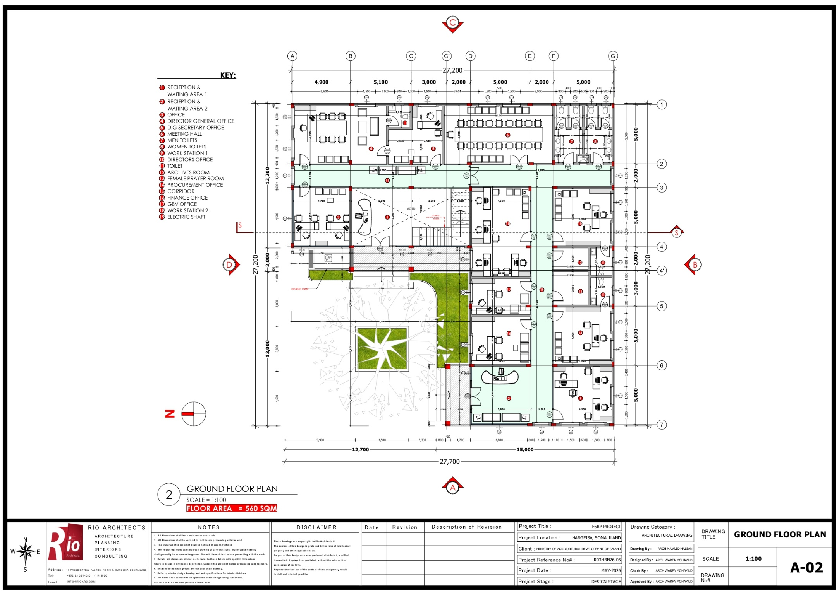
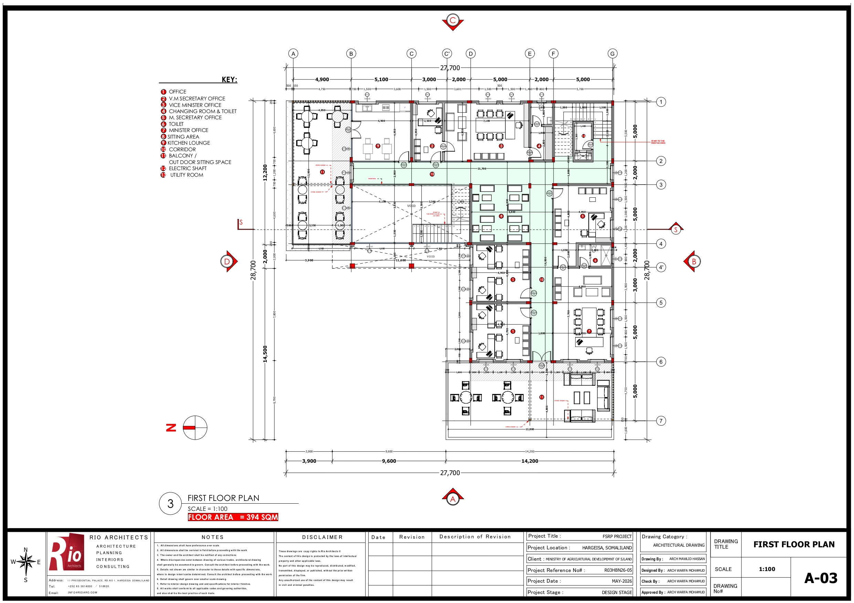

Annex 2: Official Confirmation of Land Ownership
The document below confirms that the land on which the sub-project will be constructed is public land belonging to the Ministry of Agricultural Development of the Republic of Somaliland. No land acquisition or involuntary resettlement is therefore triggered by the sub-project.
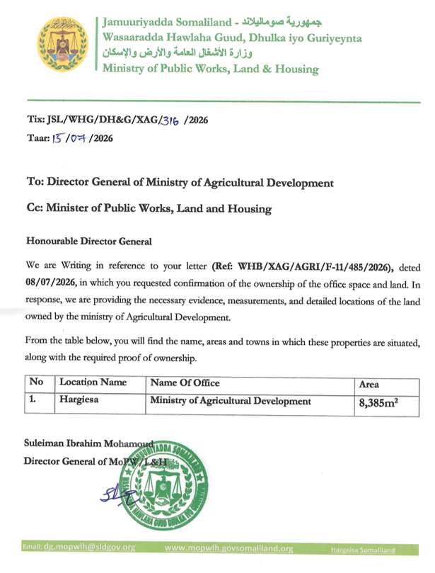

Annex 3: Notarized Declaration on the Privately Leased Room
One of the structures within the demolition footprint — a single-room structure (4m x 4m) in the southern compound of the Ministry — was occupied under a private lease arrangement. In line with Section 7.3 (item 1) and Section 7.4 of this ESMP, the property status was resolved by the Employer before any demolition or disturbance was authorized. On 17 September 2026, Mr Mahdi Ali Hussein, the person with an interest in the structure, voluntarily declared before the Al-Hudda Notary Public (Ministry of Justice, Republic of Somaliland; reference XNALH/C-259/2026) that the structure has been returned and transferred to the Ministry of Agricultural Development, and that he has been compensated for his investment in the structure and has no further claim. The notarized declaration is reproduced below.
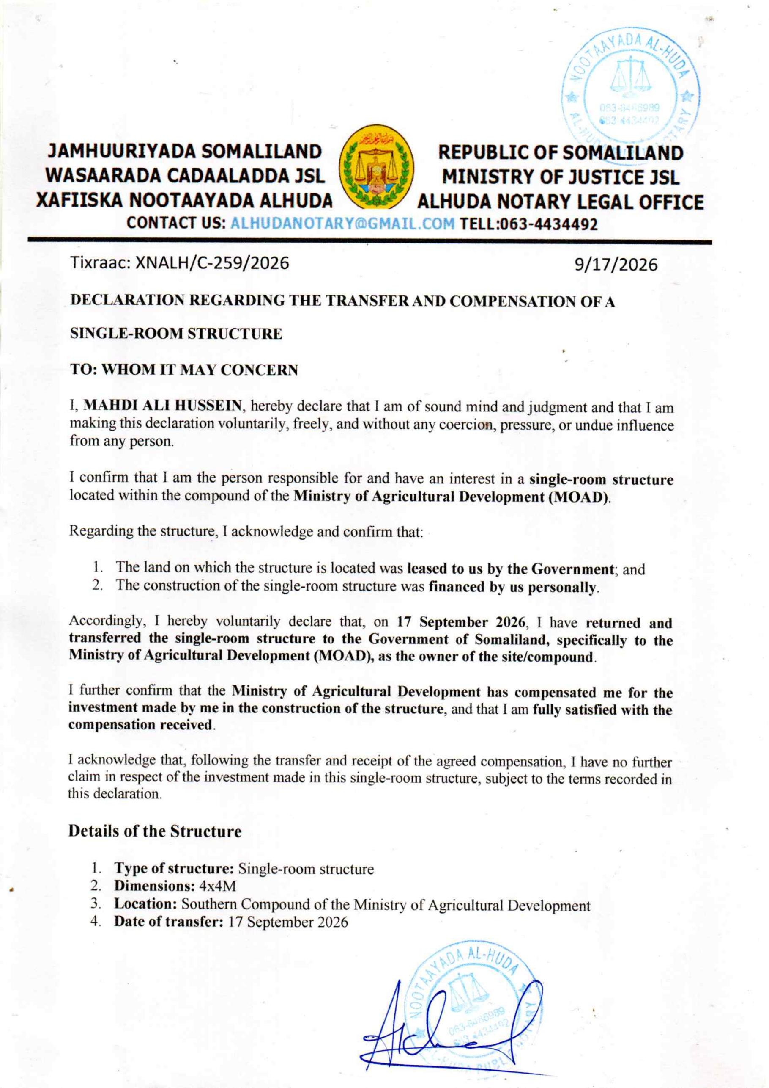

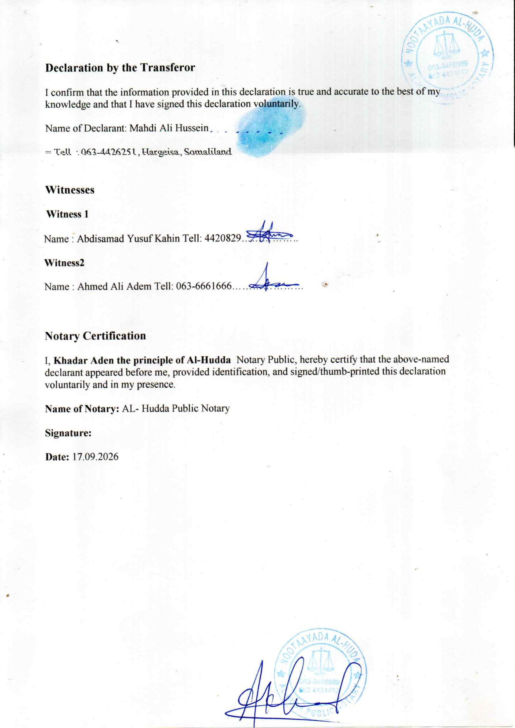

Annex 4: Brief Description of the Applicable ESSs
The Environmental and Social Framework (ESF) sets out the World Bank’s commitment to sustainable development through a Bank Policy and a set of Environmental and Social Standards. Below is a short summary of the Environmental and Social Standards (ESSs) relevant to this sub-project. ESS 6, ESS 7 and ESS 9 do not apply to this sub-project; there are no population groups that fall within the relevant criteria of ESS 7.
- ESS 1: Assessment and Management of Environmental and Social Risks and Impacts. ESS 1 sets out the Client’s responsibilities for assessing, managing and monitoring environmental and social risks and impacts associated with each stage of a project supported by the Bank through Investment Project Financing, in order to achieve environmental and social outcomes consistent with the ESSs. This standard is relevant to this sub-project, and E&S risks and impacts are managed through this ESMP.
- ESS 2: Labor and Working Conditions. ESS 2 recognizes the importance of employment creation and income generation in the pursuit of poverty reduction and inclusive economic growth. Borrowers can promote sound worker–management relationships and enhance the development benefits of a project by treating workers fairly and providing safe and healthy working conditions. ESS 2 applies to project workers including full-time, part-time, temporary, seasonal and migrant workers.
- ESS 3: Resource Efficiency and Pollution Prevention and Management. ESS 3 recognizes that economic activity and urbanization often generate pollution to air, water and land, and consume finite resources that may threaten people, ecosystem services and the environment at local, regional and global levels. This standard sets out the requirements to address resource efficiency and pollution prevention and management throughout the project life cycle, consistent with Good International Industry Practice (GIIP).
- ESS 4: Community Health and Safety. ESS 4 recognizes that project activities, equipment and infrastructure can increase community exposure to risks and impacts. Key risks and impacts of the sub-project in regard to community health and safety relate to GBV/SEA-H, pollution and security. ESS 4 addresses the health, safety and security risks and impacts on project-affected communities and the corresponding responsibility to avoid or minimize such risks, with particular attention to people who may be vulnerable. Risk mitigation measures are listed in this ESMP.
- ESS 5: Land Acquisition, Restrictions on Land Use and Involuntary Resettlement. ESS 5 recognizes that project-related land acquisition and restrictions on land use can have adverse impacts on communities and persons, causing physical displacement (relocation, loss of residential land or loss of shelter), economic displacement (loss of land, assets or access to assets, leading to loss of income sources or other means of livelihood), or both. Resettlement is considered involuntary when affected persons or communities do not have the right to refuse land acquisition or restrictions on land use that result in displacement. For these reasons, involuntary resettlement should be avoided; where unavoidable, it will be minimized and appropriate measures to mitigate adverse impacts on displaced persons will be carefully planned and implemented.
- ESS 8: Cultural Heritage. ESS 8 recognizes that cultural heritage provides continuity in tangible and intangible forms between the past, present and future. Cultural heritage is important as a source of valuable scientific and historical information, as an economic and social asset for development, and as an integral part of people’s cultural identity and practice. ESS 8 sets out measures designed to protect cultural heritage throughout the project life cycle.
- ESS 10: Stakeholder Engagement and Information Disclosure. ESS 10 recognizes the importance of open and transparent engagement between the Borrower and project stakeholders as an essential element of good international practice. Effective stakeholder engagement can improve the environmental and social sustainability of projects, enhance project acceptance and make a significant contribution to successful project design and implementation. Stakeholder engagement has been undertaken for this sub-project, as listed in the section on consultations.

Annex 5: Minutes – High-Level Project Kick-off and Safeguarding Briefing Meeting
Date | 30 July 2026
Venue | Ministry of Agricultural Development (MoAD) headquarters, Shacab area, 26 June District, Hargeisa
Chair | MoAD senior management, supported by the SL-FSRP Project Coordination Unit (PCU)
Facilitator | Abdisamad Yusuf Kahin, Social Safeguards Specialist, SL-FSRP PCU
Participants | 14 in total (4 female, 7 male, 3 youth) — MoAD top officials and ordinary staff (see attendance sheet, Annex 7)
Purpose | To formally introduce the sub-project to Ministry leadership and staff and to brief them on the World Bank environmental and social requirements that will govern the works.

1. Opening and introduction of the sub-project
The meeting opened with a welcome from MoAD management. The PCU presented the sub-project: the construction of a Ground+1 office building within the existing MoAD headquarter compound, financed under the Somaliland Food Systems Resilience Project (SL-FSRP, P177816). The presentation covered the scope of works, the constrained 498 m² site, the expected construction duration of 12–18 months, and the fact that the works will be carried out while the Ministry remains operational.

2. Overview of the World Bank Environmental and Social Framework
The Social Safeguards Specialist presented the World Bank Environmental and Social Framework (ESF) and the Environmental and Social Standards applicable to the sub-project — ESS 1, ESS 2, ESS 3, ESS 4, ESS 5, ESS 8 and ESS 10. The session explained that the sub-project is classified as Moderate risk, that an ESMP rather than a full ESIA is the applicable instrument, and that the ESMP will be legally binding on the contractor through the bidding documents and the Contractor’s ESMP (C-ESMP).

3. Leadership roles in ensuring compliance
Participants discussed the responsibilities of Ministry leadership in supervising compliance during construction. It was agreed that the Ministry will designate focal points to liaise with the PCU and the supervising engineer, that management will support the relocation arrangements required before any demolition, and that access and security coordination between MoAD guards and contractor personnel will be formally agreed before works begin.

4. High-level screening of potential social impacts on Ministry operations
An initial screening of social impacts on Ministry operations was carried out with participants. The main concerns raised were: disruption of day-to-day work by noise and dust; the status of the privately leased room within the demolition footprint; the relocation of staff occupying the five rooms to be demolished; the safe relocation of the eleven early-warning equipment units; protection of the large acacia tree; and the need for temporary sanitation facilities that do not burden the Ministry’s existing services.

5. Agreements and actions
- The status of the privately leased room is to be confirmed and resolved in writing before any demolition or disturbance (MoAD / E&S Team).
- Relocation arrangements for the users of the five rooms to be completed, and the area formally handed over, before demolition (MoAD).
- A dedicated construction gate and secure site fencing to be agreed with the Ministry before major works (MoAD / Contractor).
- Noisy activities, including loading and unloading of materials, to be scheduled outside normal office hours where feasible (Contractor).
- The project Grievance Mechanism to be publicized to all Ministry staff, with a staff-specific channel for construction-related complaints (PCU / E&S Team).
- A technical workshop to be convened to complete the detailed safeguards screening and review the design for inclusivity (PCU).
The meeting closed with agreement that the inputs received would be reflected in this ESMP and in the project-specific contractual E&S requirements set out in Section 7.3.

Annex 6: Photographs – Stakeholder Consultation and Safeguarding Meetings
The photographs below were taken during the stakeholder consultation and safeguarding briefing meetings held with MoAD officials, technical staff and other relevant stakeholders at the MoAD headquarters in Hargeisa.
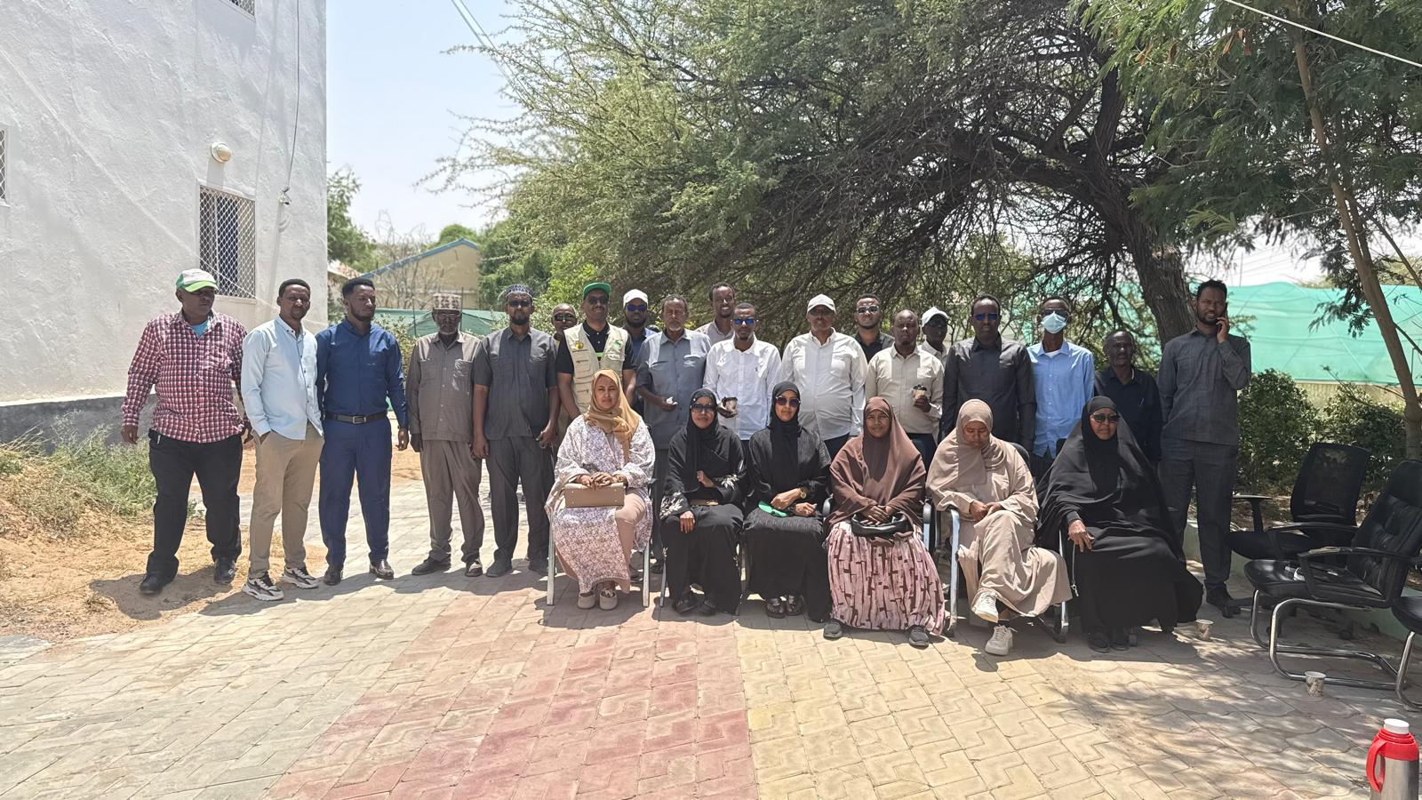
Photo 1: Group photograph of the participants of the safeguarding briefing meeting at the MoAD headquarter compound.
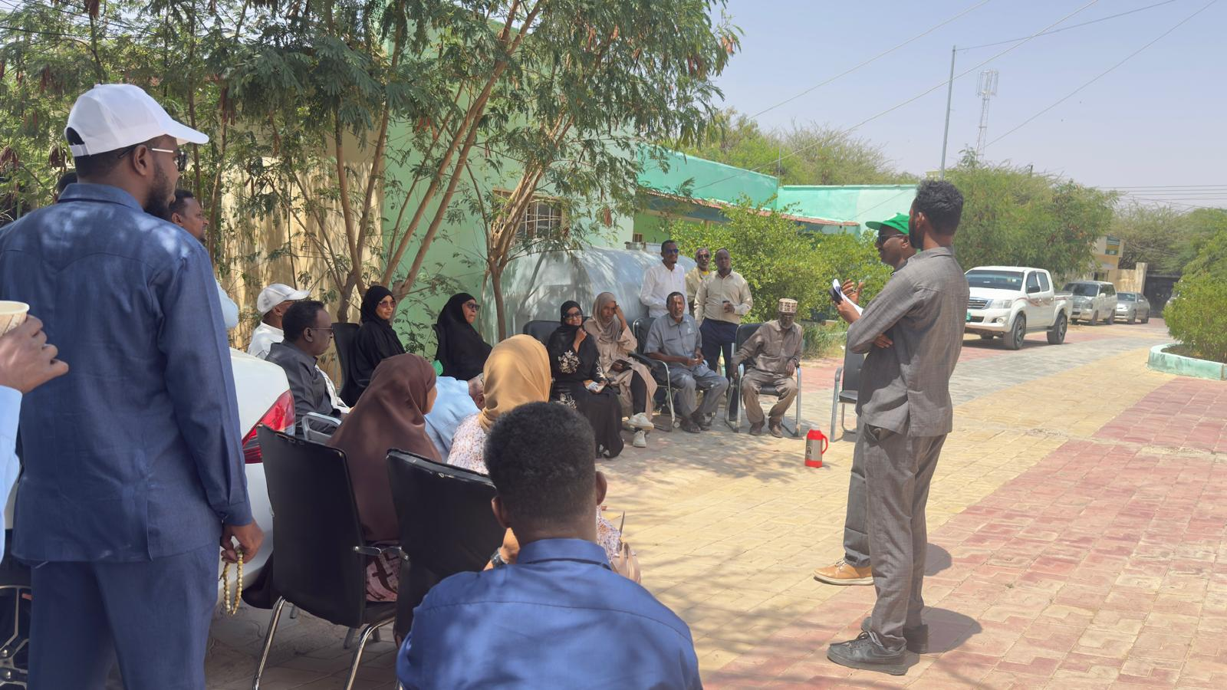
Photo 2: The PCU safeguards team presenting the sub-project and the World Bank ESF requirements to participants.

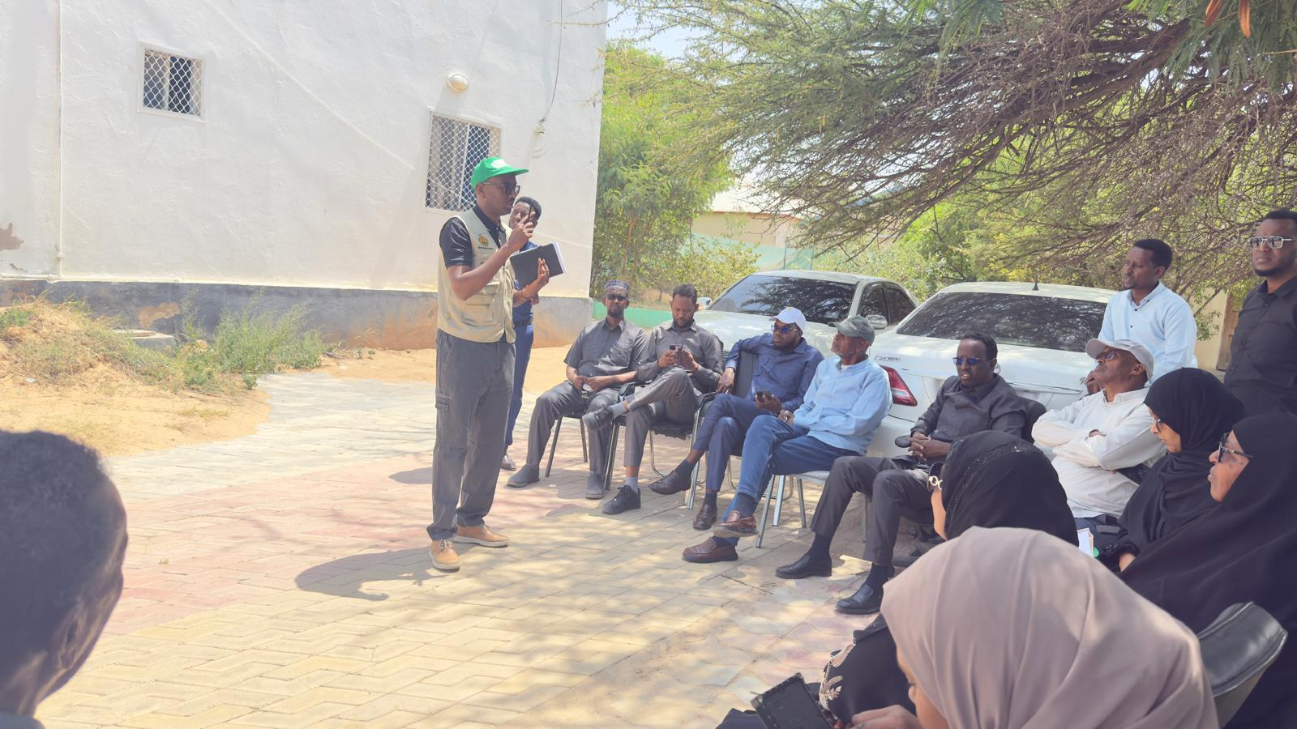
Photo 3: Briefing session on environmental and social risks, OHS measures and the project Grievance Mechanism.
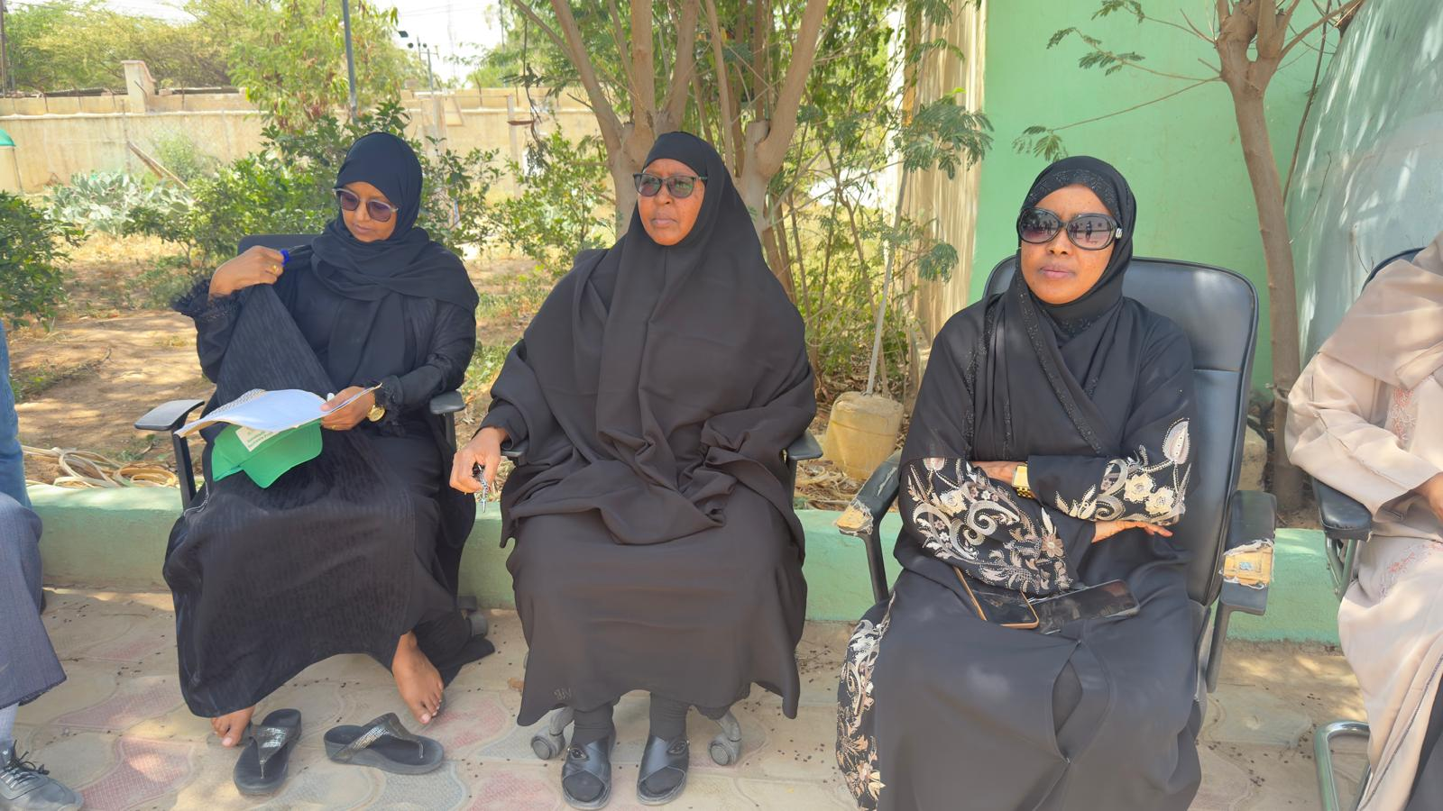
Photo 4: Women participants of the Ministry taking part in the consultation and the review of the design for inclusivity.

Annex 8: Minutes – Technical Workshop on E&S Safeguards and Design
Date | 1 September 2026
Venue | Ministry of Agricultural Development (MoAD) headquarters, Shacab area, 26 June District, Hargeisa
Facilitator | Abdisamad Yusuf Kahin, Social Safeguards Specialist, SL-FSRP PCU
E&S Team Confirmation | Abdisamad Yusuf Kahin (MoAD) and Hamda Adan Ahmed (MoAD)
Participants | 26 in total (approx. 5 female, 21 male) — MoAD technical team, department representatives and relevant stakeholders of the proposed site (see signed attendance sheet, Annex 9)
Purpose | To provide information on the proposed activity, identify environmental and social risks and impacts, obtain stakeholder views, and document concerns, recommendations and agreed actions.

1. Detailed safeguards screening
Participants worked through the site-specific screening checklist (reproduced at Annex 10) and identified the following site-specific issues: an existing room within the proposed construction area belongs to a private individual and will be affected by construction, requiring fair and transparent compensation (subsequently resolved — see the notarized declaration at Annex 3); five existing rooms are expected to be demolished, affecting their current users; an existing farm is located within the construction area and contains approximately 36 fruit trees; dust and noise will be generated within an occupied compound; and construction traffic will mix with normal Ministry movement. The screening also confirmed that the site contains no sensitive ecological features beyond the farm noted above, no known cultural or archaeological sites, and that the land is public land belonging to the Ministry.

2. Worker management protocols to minimize impact on staff
It was agreed that the contractor will be required to establish a separate construction entrance, fence the construction area before major works, restrict workers to the fenced area, and provide its own temporary toilets, sanitation and secure storage rather than using Ministry facilities. The contractor will also bring construction water from outside so that the Ministry’s existing supply is not burdened. All contractor personnel, subcontractors and security staff will sign a project-specific Code of Conduct before starting work.

3. Review of the building design for inclusivity
The design was reviewed against accessibility and gender considerations. Participants recommended step-free access at the main entrance, at least one accessible toilet, clearly separated and lockable sanitation facilities for women and men on each floor, adequate lighting in circulation areas, and retention of the mature acacia tree and the courtyard for shade and ventilation. The PCU confirmed that these features are reflected in the design layout attached at Annex 1.

4. Grievance mechanism for staff
A staff-specific grievance channel for construction-related issues was introduced. Participants were shown how to submit a complaint in person, by phone, through the complaint box to be installed at the site entrance, or by email, and were informed of the three-working-day acknowledgement and 15-working-day resolution targets. The separate, confidential GBV/SEA/SH channel and the MoAD toll-free line 9665 were explained, as was the right to escalate unresolved cases to the World Bank Grievance Redress Service.

5. Occupational health and safety and what to expect during construction
The PCU explained the OHS measures that the contractor will implement — PPE, site induction, toolbox talks, warning signage, first-aid facilities and a qualified OHS officer — and what staff should expect during the works in terms of noise, dust, vehicle movement and temporary access restrictions. Staff were asked to keep clear of the fenced construction area at all times.

6. Questions, feedback and agreed actions
- Confirm and document the relocation of the eleven early-warning equipment units before construction reaches that area (MoAD technical department / Contractor).
- Agree fair compensation for the fruit trees on the existing farm within the construction footprint before land clearance (MoAD / Contractor).
- Mark and physically protect the large acacia tree and its root protection zone before site clearance (Contractor / Engineer).
- Agree written security and access-control arrangements between MoAD guards and contractor guards (MoAD / Contractor).
- Schedule deliveries and noisy works outside peak office hours and give advance notice of unavoidable disruptive activities (Contractor).
- Publicize the grievance channels at the Ministry entrance and at the site entrance (PCU / E&S Team).
- Reflect the accessibility and gender-related design recommendations in the final design and in the bidding documents (PCU).
The participants endorsed the draft ESMP and the project-specific contractual E&S requirements, subject to the actions listed above. The inputs received have been incorporated into Sections 6, 7 and 9 of this ESMP.

Annex 9: Attendance Sheet – Technical Workshop on E&S Safeguards and Design
Meeting held on 1 September 2026 at the MoAD headquarters, Hargeisa. Total attendance: 26 participants (approx. 5 female, 21 male). The signed original attendance sheet, including the key E&S issues raised and the E&S team confirmation, is reproduced below.
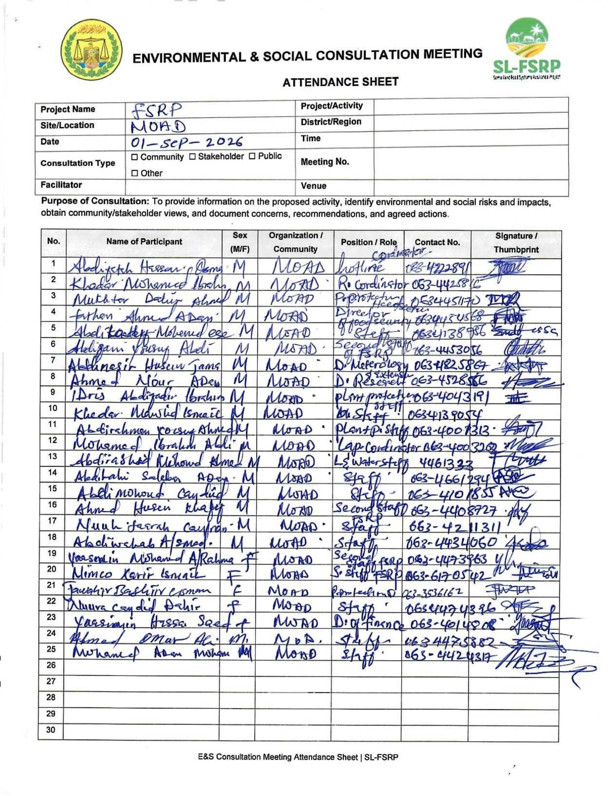

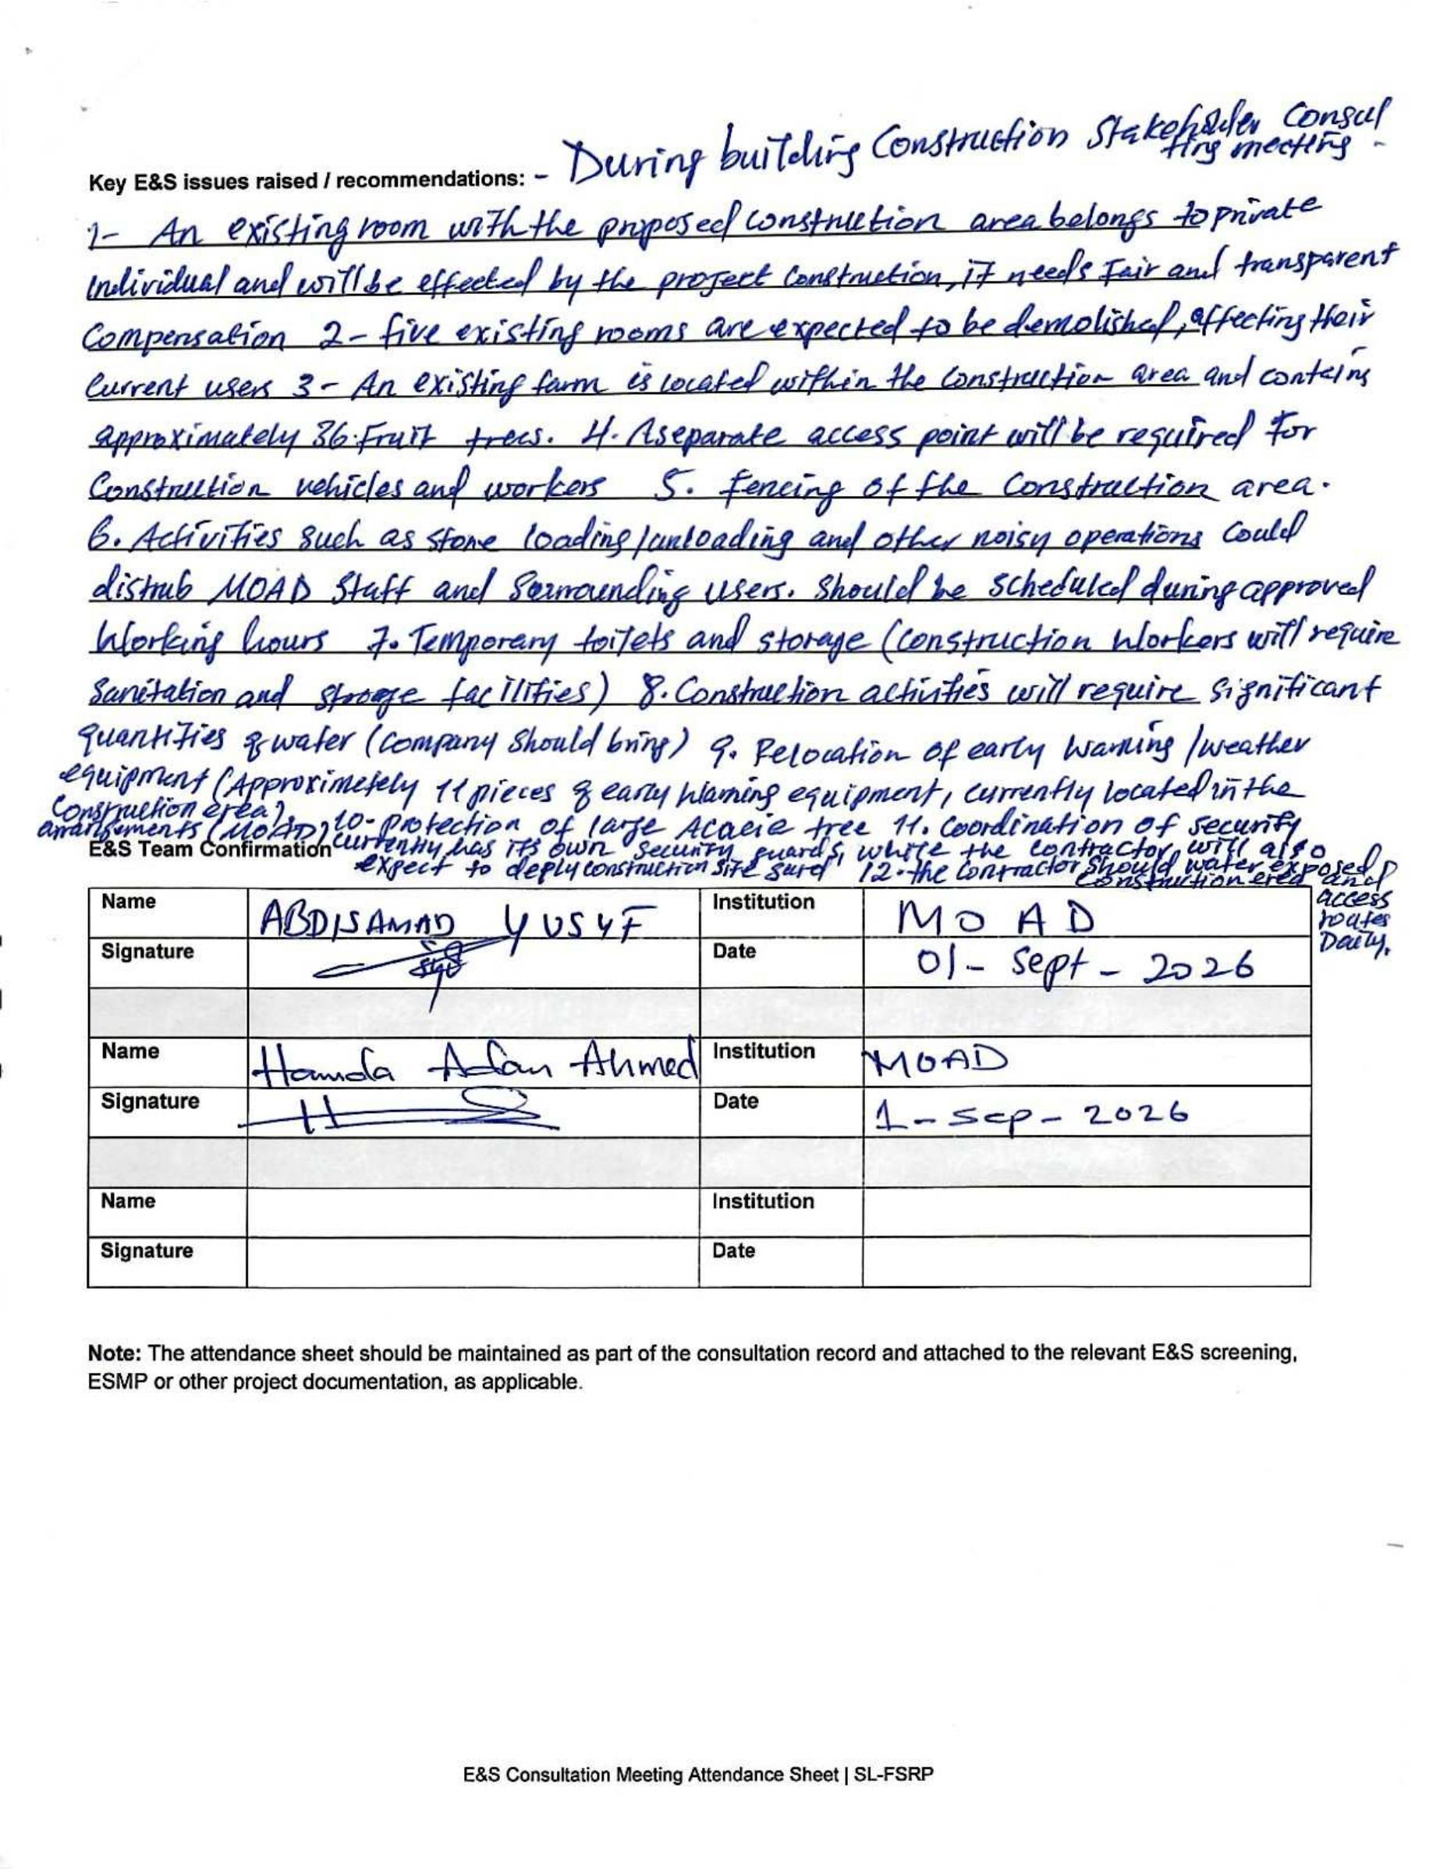

Annex 10: MoAD Office Building E&S Screening Checklist
Projects are screened for their inherent social and environmental risks regardless of planned mitigation and management measures. It is necessary to identify potential inherent risks in the event that mitigation measures are not implemented or fail. This means that risks should be identified as if no mitigation or management measures were to be put in place.

Section A: General information
Date of screening | 4 September 2026
Activity / sub-project title | Construction of office building works for MoAD, Somaliland
Activity / sub-project component | Institutional capacity building
Implementing partner | N/A
Proposed activity duration | 12–18 months
E&S screening team leader and contact details | Abdisamad Yusuf Kahin (Abdisamad.kahin@sl-fsrp.org)
Site / activity location | MoAD Somaliland HQ premises
New / rehabilitation project | New
Project description | Construction of a G+1 office building for the Ministry of Agricultural Development (MoAD), Republic of Somaliland. The building will serve as the Ministry’s headquarters and is located within the existing MoAD headquarters compound.

Section B: Potential environmental and social risks and impacts of the activity
At this stage, questions are answered without considering the magnitude of impact — only “yes”, “no” or “I don’t know” are applicable answers.
Risk category / question | Yes | No | I don’t know | If “yes”, refer to: | Comments
ESS 1: Assessment and Management of Environmental and Social Risks and Impacts
Is an Environmental and/or Social Assessment required where the project is undertaken? | ✓ |  |  | ESMF
Is there a risk of diversion of project benefits? |  | ✓ |  | Stakeholder Engagement Plan (SEP)  Grievance Redress Mechanisms (GRM)
Is there a risk of lack of monitoring of project activities due to remoteness of location and insecurity? |  | ✓ |  | MoAD headquarter premises
Is there a risk that project benefits may not reach truly vulnerable populations? |  | ✓ |  | Stakeholder Engagement Plan (SEP)
Is there a risk that the activity will cause population influx from neighbouring areas? |  | ✓ |  | Stakeholder Engagement Plan (SEP)
Is there a risk that the selection of the activity location or beneficiaries will lead to conflict? |  | ✓ |  | Grievance Redress Mechanisms (GRM)
ESS 2: Labour and Working Conditions
Does the activity include any of the known labour rights / ESS 2 non-compliance risks in Somaliland (child and forced labour)? | ✓ |  |  | Labor Management Procedures (LMP)  Occupational Health and Safety Plan (OHS)
Does the activity include a construction component? | ✓ |  |  | Labor Management Procedures (LMP)  C-ESMP  Occupational Health and Safety Plan (OHS)
Does the activity include labour-intensive manufacturing? |  | ✓ |  | Labor Management Procedures (LMP)  Occupational Health and Safety Plan (OHS)
Does the activity include primary agricultural activities? |  | ✓ |  | Labor Management Procedures (LMP)  Occupational Health and Safety Plan (OHS)
Will the activity require a larger contractor workforce? | ✓ |  |  | Labor Management Procedures (LMP)  Occupational Health and Safety Plan (OHS)  C-ESMP
Is there a security risk for project workers? |  | ✓ |  | Security Management Plan (SMP)
Is there a risk of lacking OHS for workers at the construction site? | ✓ |  |  | Occupational Health and Safety Plan (OHS)  Pest Management Plan (PMP)
Is there a risk of delayed payment of workers? |  | ✓ |  | Labor Management Procedures (LMP) | In Somaliland, both skilled and unskilled labourers are typically hired as casual workers and paid on a daily basis. As a result, there is generally no risk of delayed payments.
Is there a risk that workers are underpaid? |  | ✓ |  | Labor Management Procedures (LMP)
Is there a risk that women will not be included in deployment in equal numbers? | ✓ |  |  | Labor Management Procedures (LMP)  GBV Action Plan | Since this is construction work, which is physically demanding, it is traditionally considered a male-dominated activity in Somaliland. Culturally, women are not commonly involved in heavy labour but may participate in lighter tasks such as watering, preparing food and other supportive roles.
ESS 3: Resource Efficiency and Pollution Prevention and Management
Will the activity result in the production of solid waste? (directly by the project or by the workforce) | ✓ |  |  | Waste Management Plan, based on WBG Environmental, Health and Safety General Guidelines  Pest Management Plan (PMP)  C-ESMP
Will the activity result in the production of toxic or hazardous waste? (e.g. used oils, inflammable products, pesticides, solvents, pharmaceutics, industrial chemicals, ozone-depleting substances) | ✓
Will the activity result in the generation of dust and noise? | ✓ |  |  | C-ESMP
Will the activity result in soil erosion? |  | ✓ |  | C-ESMP
Will the activity produce effluents (waste water)? |  | ✓ |  | C-ESMP  Waste Management Plan
Will the activity result in increased levels of vibration from construction machinery? | ✓ |  |  | C-ESMP
Will the project produce air pollution? (e.g. significant greenhouse gas emissions, dust emissions and other sources) | ✓ |  |  | C-ESMP
Will the activity disturb any fauna and flora? |  | ✓ |  | C-ESMP
Can the project affect the surface or groundwater in quantity or quality? (e.g. discharges, leaking, leaching, boreholes, etc.) |  | ✓
Will the project require use of chemicals? (e.g. fertilizers, pesticides, paints, etc.) |  | ✓
Is there any risk of accidental spill or leakage of material? |  | ✓
ESS 4: Community Health and Safety
Is there a risk of community exposure to pesticides? |  | ✓ |  | Pest Management Plan (PMP)
Is there a risk of communal drinking water pollution through pesticides? |  | ✓ |  | Pest Management Plan (PMP)
Is there a risk of increased GBV/SEAH cases due to labour influx? |  | ✓ |  | GBV/SEAH Action Plan  Labor Management Procedures (LMP)
Is there a risk of spread of communal diseases due to labour influx? | ✓ |  |  | Labor Management Procedures (LMP)  C-ESMP
Is there a security risk to the community triggered by project activities? |  | ✓ |  | Security Management Plan (SMP)
Does the activity have the potential to upset community dynamics? |  | ✓ |  | Stakeholder Engagement Plan (SEP)  Grievance Redress Mechanisms (GRM)
Will the activity include payments or cash transfers? | ✓ |  |  | Stakeholder Engagement Plan (SEP)  Grievance Redress Mechanisms (GRM)
Will the activity expose community members to physical hazards on the project site? |  | ✓ |  | C-ESMP
Will the activity pose traffic and road safety hazards? |  | ✓ |  | C-ESMP
Will the activity include debris removal that may pose a safety hazard for the community? | ✓ |  |  | Waste Management Plan
Is there a possibility that the activity contaminates open wells? |  | ✓ |  | Waste Management Plan  C-ESMP
Is there a possibility that the activity spreads pathogens and other pollutants (e.g. latrines)? | ✓ |  |  | Waste Management Plan  C-ESMP
Can the activity contribute to the spread of disease (e.g. health facilities)? | ✓ |  |  | Waste Management Plan
ESS 5: Land Acquisition, Restrictions on Land Use and Involuntary Resettlement
Will the project lead to the displacement of a population? (e.g. forceful relocation, relocation of the local community) |  | ✓ |  | Resettlement Policy Framework (RPF)  Resettlement Action Plan (RAP) | The land is owned by Somaliland.
Will the displacement / resettlement affect IDPs? |  | ✓ |  | Resettlement Policy Framework (RPF)  Resettlement Action Plan (RAP)
Is the project located in a conflict area, or does it have the potential to cause social problems and exacerbate conflicts, for instance related to land tenure and access to resources (e.g. a new road providing unequal access to a disputed land)? |  | ✓ |  | Stakeholder Engagement Plan (SEP)  Grievance Redress Mechanisms (GRM) | The project is in the city of Hargeisa.
Would the project potentially discriminate against women and girls based on gender, especially regarding participation in design and implementation or access to opportunities and benefits? |  | ✓ |  | Stakeholder Engagement Plan (SEP)  Grievance Redress Mechanisms (GRM)
Is there a risk that the activity leads to loss of income, assets or means of livelihoods? |  | ✓ |  | Resettlement Policy Framework (RPF)  Resettlement Action Plan (RAP)
Will the activity lead to disputes over land ownership? |  | ✓ |  | Resettlement Policy Framework (RPF)  Resettlement Action Plan (RAP)
Will the activity lead to blocked access to people in the area? |  | ✓ |  | Resettlement Policy Framework (RPF)  Resettlement Action Plan (RAP)
Will the activity require acquisition of land or physical buildings or infrastructure? | ✓ |  |  | Resettlement Policy Framework (RPF)  Resettlement Action Plan (RAP) | This is public land belonging to the Ministry of Agricultural Development.
ESS 6: Biodiversity Conservation and Sustainable Management of Living Natural Resources
Are pesticides used in the activity likely to affect important natural resources or ecological functions? |  | ✓ |  | Pest Management Plan (PMP)
Will the activity impact sensitive areas? |  | ✓
Is there a risk that the activity causes changes in land form and habitat, habitat fragmentation, blockage of migration routes, water consumption and contamination? |  | ✓
Is there a risk that the activity causes loss of precious ecological assets? |  | ✓
ESS 10: Stakeholder Engagement and Information Disclosure
Is there a risk that the activity fails to incorporate measures to allow meaningful, effective and informed consultation of stakeholders, such as community engagement activities? |  | ✓ |  | Stakeholder Engagement Plan (SEP)
Is there a historical exclusion of disabled persons in the area? |  | ✓ |  | Stakeholder Engagement Plan (SEP)
Is there a lack of social baseline data? |  | ✓ |  | ESMF
Is there a lack of community consultations by the government generally? |  | ✓ |  | Stakeholder Engagement Plan (SEP)
Are women likely to participate in decision-making processes in regard to the activity? | ✓ |  |  | Stakeholder Engagement Plan (SEP)
Is there a risk that exclusion of beneficiaries leads to grievances? |  | ✓ |  | Stakeholder Engagement Plan (SEP)  Grievance Redress Mechanisms (GRM) — see ESMF
Is there a risk that the activity will have poor access to beneficiaries? |  | ✓ |  | Stakeholder Engagement Plan (SEP)  Grievance Redress Mechanisms (GRM) — see ESMF

Summary of the screening process
Risk / impact identified | Individual risk rating | Mitigation
ESS 1: need for a structured E&S assessment and management process. | Moderate | Develop and implement a project-specific ESMP.
ESS 2: labour rights non-compliance (child/forced labour), poor working conditions and OHS hazards. | Moderate | Implement Labor Management Procedures (LMP) and a robust Occupational Health and Safety (OHS) Plan.
ESS 3: pollution from solid and hazardous waste, dust, noise and air emissions from construction activities. | Moderate | Implement a Waste Management Plan and site-specific controls within a Contractor’s ESMP (C-ESMP).
ESS 4: spread of communicable diseases due to temporary labour influx. | Moderate | Implement worker health and hygiene protocols within the LMP and C-ESMP; manage waste and debris according to a Waste Management Plan.
ESS 10: need for active inclusion of women in decision-making. | Moderate | Implement targeted consultation and participation strategies as outlined in the Stakeholder Engagement Plan (SEP).

Annex 11: Demolition and Relocation E&S Management Matrix

Environmental and Social Management Matrix – Demolition of Six Existing Rooms and Relocation of Small Demonstration Farm
Activity: Demolition of six existing rooms within the proposed MOAD construction site and relocation of a small demonstration farm containing approximately 36 fruit trees. Five rooms are used by the MOAD Department of Plant Protection and one room was leased to a private occupant. Compensation for the leased room has been provided and agreed with the occupant, while alternative office arrangements for the five MOAD rooms are ready and will be completed before demolition. The small demonstration farm containing approximately 36 fruit trees will also be relocated to facilitate the proposed construction works.
Environmental/Social Aspect | Potential Impact/Risk | Mitigation and Management Measures | Measurable Monitoring Indicators | Frequency | Responsibility
Pre-demolition assessment | Unexpected structural, environmental or safety hazards | Conduct a documented pre-demolition inspection covering structural condition, utilities, hazardous materials, access routes, adjacent facilities, retained assets and the demonstration farm. | Pre-demolition inspection completed and approved before demolition starts; inspection report available. | Before demolition | Contractor / Engineer / E&S-OHS Officer
Compensation – leased room | Economic displacement or dispute | The agreed compensation for the leased room has been provided. | 100% agreed compensation provided; signed compensation/settlement documentation available | It has already resolved | MOAD / PCU Safeguarding
Relocation – five MOAD rooms | Disruption to departmental operations and staff | Alternative office arrangements for the five MOAD rooms shall be completed and ready for occupation before demolition. Coordinate relocation with the Department of Plant Protection to avoid disruption to essential functions. | 100% of five rooms relocated/ready for occupation before demolition; 0 occupants remaining in the demolition area at commencement. | Before demolition | MOAD / Department of Plant Protection / Contractor
Relocation of demonstration farm | Loss of productive space, fruit trees and demonstration activities | Relocate the small demonstration farm before construction affects the area. Identify and prepare the receiving site in consultation with the responsible MOAD staff/farm users. Where technically feasible, transplant suitable fruit trees; where transplantation is not feasible, document the affected trees and implement an agreed replacement/replanting measure. | Relocation plan approved before works; 100% of affected farm area addressed; 36 fruit trees inventoried and accounted for; replacement/transplanting records maintained. | Before site clearance / during relocation | MOAD / Contractor / E&S Officer
Structural safety | Collapse of walls/roof and injury to workers or third parties | Implement an approved demolition method statement. Demolish progressively from top to bottom, establish exclusion zones and prevent uncontrolled collapse. | Approved demolition method statement available; 100% workers briefed; 0 uncontrolled collapses. | Daily | Contractor / Engineer / OHS Officer
Worker OHS | Injury from falling materials, dust, noise, machinery and tools | Provide appropriate PPE, toolbox talks, exclusion zones and competent supervision. | 100% demolition workers provided with and using required PPE; toolbox talks recorded; 0 major demolition-related injuries. | Daily | Contractor / OHS Officer
Dust and air quality | Dust affecting workers, MOAD staff and surrounding areas | Use water suppression during dusty activities, cover demolition debris during transport and minimize unnecessary disturbance of dry materials. | Dust suppression implemented during 100% of dusty activities; dust complaints recorded and addressed. Dust and emission levels are within the international permissible limits | Daily | Contractor / E&S-OHS Officer
Noise and vibration | Disturbance to MOAD staff and surrounding receptors | Restrict demolition to approved working hours, maintain equipment and avoid unnecessary idling or excessive noise. | 100% compliance with approved working hours; noise complaints recorded and addressed; equipment maintenance records available; and noise levels are within the international permissible limits. | Daily | Contractor / Site Supervisor
Hazardous materials | Exposure to asbestos, lead-based paint or other hazardous substances | Inspect the rooms before demolition. If suspected hazardous materials are identified, stop affected work and arrange appropriate assessment, handling and disposal by competent personnel. | Hazardous-material screening completed; 0 hazardous materials disturbed without appropriate controls. | Before/during demolition | Contractor / E&S-OHS Officer
Utilities | Electrical shock, fire, or other incidents | Identify and safely disconnect/isolate electricity, water, drainage and other services before demolition. Verify isolation before work starts. | 100% relevant utilities isolated and verified before demolition. | Before demolition | Contractor / Engineer / Utility Providers
Demolition waste | Uncontrolled dumping, obstruction and environmental contamination | Segregate reusable/recyclable materials and transport demolition waste to approved disposal or reuse locations. No open burning or uncontrolled dumping. | 100% demolition waste transported to approved/reuse locations; 0 uncontrolled dumping or burning. | Daily / per load | Contractor / E&S Officer
Traffic and waste transport | Accidents involving vehicles, pedestrians and workers | Establish safe loading areas, secure loads and use appropriate traffic controls during removal of demolition materials. | 100% loads secured; traffic controls implemented during removal; 0 major transport-related incidents. | During transport | Contractor / Traffic Police
Community/MOAD access | Unauthorized entry or injury to staff/visitors | Barricade and sign the demolition area and maintain safe access to remaining MOAD offices and facilities. | 100% demolition area barricaded/signposted; 0 unauthorized-entry incidents. | Daily | Contractor / Security / Site Supervisor
Retained mature acacia tree | Damage from demolition machinery, debris or site activities | Clearly mark and protect the mature acacia tree incorporated into the new design. Establish a protection zone with no material storage, parking, excavation or machinery operation within the protected area. | Protection zone established before demolition; 0 damage to the retained tree; photographic inspection records maintained. | Daily / weekly | Contractor / E&S Officer / Engineer
Existing MOAD assets and equipment | Damage to retained facilities or equipment | Identify and protect or relocate sensitive equipment and facilities before demolition. Maintain safe separation from demolition activities. | 100% identified sensitive assets protected/relocated; 0 damage attributable to demolition. | Before/during demolition | Contractor / MOAD / Engineer
Emergency preparedness | Delayed response to injury, collapse, fire or other emergencies | Maintain first-aid equipment, fire extinguishers, emergency contacts, evacuation routes and clear emergency access. Brief all demolition workers on emergency procedures. | Emergency equipment inspected; 100% workers briefed; emergency contacts displayed; incidents recorded and investigated. | Daily / before work | Contractor / OHS Officer
Labor and working conditions | Unsafe employment conditions, child/forced labor or worker grievances | Implement ESS2 requirements, provide clear employment terms, wages and working hours, prohibit child and forced labor, implement the Code of Conduct and provide access to the worker GRM. | 100% workers registered and inducted; 100% sign Code of Conduct; 0 child/forced labor cases. | Before work / monthly | Contractor / E&S-OHS Officer
Security personnel | Misconduct, intimidation or excessive use of force | Security personnel shall be appropriately trained and briefed on conduct, human rights and proportionate response. Security complaints/incidents shall be recorded and investigated. | 100% security personnel trained/briefed; 0 substantiated cases of abuse or excessive force. | Before deployment / monthly | Contractor / Security Provider / E&S Officer
Post-demolition site condition | Residual debris, unsafe areas and construction hazards | Remove all demolition debris, level and secure the area, close/protect excavations and confirm that the site is safe before subsequent construction works. | 100% debris removed; post-demolition inspection completed; 0 unsecured hazards remaining. | Upon completion | Contractor / Engineer / E&S Officer

Critical Pre-Demolition Conditions
Demolition shall not commence until the following conditions have been verified:
Leased room: Agreed compensation has been provided and documented.
Five MOAD rooms: Alternative office arrangements are ready and the users have been relocated.
Demonstration farm: The relocation arrangement for the small farm has been agreed and the receiving area is ready.
36 fruit trees: All trees have been inventoried and an agreed transplantation/replanting or replacement arrangement is documented.
Utilities: Electricity, water and other relevant services have been safely isolated.
Demolition method statement: Approved and communicated to all relevant workers.
Retained acacia tree: Protection zone established and clearly marked.
Emergency arrangements: First aid, fire protection, emergency contacts and access arrangements are in place.
Demolition area: Properly barricaded and secured against unauthorized access.

